NOAA NESDIS-NGDC

MEPED Telescope Data Processing
ALGORITHM THEORETICAL BASIS DOCUMENT
Version 1.0

TITLE: MEPED TELESCOPE DATA PROCESSING THEORETICAL BASIS DOCUMENT VERSION 1.0

AUTHORS:
Dr. Janet Green

MEPED TELESCOPE DATA PROCESSING ALGORITHM THEORETICAL BASIS DOCUMENT VERSION HISTORY SUMMARY

Version | Description | Revised Sections | Date
1.0 | Created by Janet Green | New Document | Mar 2013

TABLE OF CONTENTS
TABLE OF CONTENTS 7
LIST OF FIGURES 9
LIST OF TABLES 10
LIST OF ACRONYMS 11
ABSTRACT 12
1.0 INTRODUCTION 13
1.1 Purpose of This Document 13
1.2 Who Should Use This Document 13
1.3 Inside Each Section 13
1.4 Related Documents 14
1.5 Revision History 14
2.0 OBSERVING SYSTEM OVERVIEW 14
2.1 Product Generated 14
2.2 Instrument Characteristics 15
3.0 ALGORITHM DESCRIPTION 22
3.1 Algorithm Overview 22
3.2 Processing Outline 22
3.3 Algorithm Input 22
3.3.1 Primary Sensor Data 22
3.3.2 Ancillary Data 23
3.4 Processing Procedure 28
3.4.1 Read the Level-1B files and Calibration Tables 28
3.4.2 Take the ones complement of the sensor data 28
3.4.3 Decompress data to raw counts 29
3.4.4 Calculate magnetic parameters needed to map to the ionosphere 29
3.4.5 Check for backwards times and resort 29
3.4.8 Change counts to physical units using a calibration table 29
3.4.9 Calculate pitch angles at the satellite and at the foot of the field line 30
3.5 Algorithm Output 31
4.0 TESTING THE ALGORITHM PERFORMANCE 32
4.1 Input Data Sets 32
4.2 Comparisons of Test Data and Algorithm Output 32
5.0 PRACTICAL CONSIDERATIONS 36
5.1 Numerical Computation Considerations 36
5.2 Programming and Procedural Considerations 36
5.3 Quality Assessment and Diagnostics 36
5.5 Algorithm Validation 37
6.0 ASSUMPTIONS AND LIMITATIONS 37
6.1 Performance 37
6.2 Assumed Sensor Performance 38
6.3 Pre-Planned Product Improvements 38
7.0 REFERENCES 38 38
Appendix A: Data Tables 38
Appendix B: Outputs 39
Appendix C: Measured Response Functions 46
Figure C-1 Response of the proton telescope detector to electrons 46
Appendix D: Level 1B file format and Telemetry Description 47

LIST OF FIGURES

Figure 2-1: Schematics showing the MEPED proton telescopes (left) and electron telescopes (right)

Figure 2-2 Energy deposited by protons in the proton telescope front D1 detector

Figure 2-3 Energy deposited by protons in the proton telescope rear D2 detector

Figure 2-4 Energy loss for electrons and protons in the electron telescope detectors

Figure 2-5 Alignment of the MEPED telescopes on the POES satellites

Figure 3-1 Meaured response functions for the electron 0 and 90 degree telescopes

Figure 3-2 Bow tie curves for the proton telescopes energy channels p1 through p5.
Figure 3-3: Bow ties for the electron channels.

Figure 4-1 Comparison of legacy and new processing magnetic field components

Figure 4-2 Comparison of legacy and new processing pitch angles

Figure 4-3 Comparison between legacy and new processing output of the location of the foot of the field line

Figure C-1 Response of the proton telescope detector to electrons

Figure C-2 Response of the proton telescope detector to protons

LIST OF TABLES

Table 2-1 Discriminator level thresholds for the proton detectors
Table 2-2 Proton telescope logic
Table 2-3 Discriminator thresholds for the electron detectors
Table 2-4 Logic for the electron detectors
Table 3-1 L1b MEPED sensor data input to level 2 processing
Table 3-2 Geometric factors and center energies for proton and electron curves from the bow tie analysis
Table A-1 Data decompression look-up table
Table B-1 Processing output variables
Table D-1: The byte by byte description of the contents of the header record of a SEM incremental file.
Table D-2: Description of Data Record
Table D-3: SEM-2 data allocations in TIP words 20 and 21 for a single TIP 32 second major frame.

LIST OF ACRONYMS
ATBD | Algorithm Theoretical Basis Document
eV | electron volt
keV | kilo-electron-volt
L1b | Level 1b
L2 | Level 2
MeV | mega-electron-volt
TED | Total Energy Detector
NGDC | National Geophysical Data Center
NESDIS | National Environmental Satellite, Data, and Information Services
POES | Polar Orbiting Environmental Satellite
MetOp | Meteorological Operational
MEPED | Medium Energy Proton and Electron Detector

ABSTRACT

This document provides a description of the algorithms and procedures used to transform the output from the Medium Energy Proton and Electron Detector (MEPED) telescopes on the POES/MetOp satellites into higher level data products such as differential particle flux. Error propagation, validation and examples of the algorithm are discussed. The logical flow of the algorithm is outlined.

1.0 INTRODUCTION

1.1 Purpose of This Document

The purpose of this document is to describe the algorithms used by the NOAA National Geophysical Data Center (NGDC) processing system to translate the measurements from the MEPED telescopes into physically meaningful values. The MEPED instrument is part of the Space Environment Monitor (SEM)-2 instrument suite on the POES/MetOp satellites. The MEPED instrument consists of 2 distinct parts: telescopes and dome detectors. This ATBD describes only the processing of the telescope data. The processing of the dome data is described in a separate ATBD. (The SEM-2 suite also includes the TED instrument that is described in a separate ATBD). The algorithms and processing system described here were implemented after April 2013. Prior to April 2013 the SEM-2 data was processed using a system developed and maintained by the NOAA Space Weather Prediction Center. That system failed on Jan 1 2013. Many of the processing techniques used are similar but the code and file formats are new. The old system is described by the document referenced in section 1.4.

1.2 Who Should Use This Document

All users of the MEPED telescope data should refer to this document to be cognizant of what the instrument can provide, how the data is processed, and potential limitations of the dataset that could impact interpretation.

1.3 Inside Each Section
Section 2.0 OBSERVING SYSTEM OVERVIEW:
Describes the POES/MetOp MEPED instrument and the measurements that serve as input to the processing.

Section 3.0 ALGORITHM DESCRIPTION:
Describes the development, theory and mathematics of the algorithm. Describes the logical flow of the algorithm, including input and output flow.

Section 4.0 TESTING:
Describes the methods used to test the algorithm and characterize the performance and the data product quality.

Section 5.0 PRACTICAL CONSIDERATIONS:
Discusses issues involving numerical computation, programming and procedures, quality assessment and diagnostics and exception handling.

Section 6.0 ASSUMPTIONS AND LIMITATIONS:
Describes assumptions made in the implementation, validation, testing, and error handling of the algorithm.

Section 7.0 REFERENCES:
Provides all references mentioned in the ATBD.

1.4 Related Documents
Polar Orbiting Environmental Satellite Space Environment Monitor-2: Instrument Descriptions and Archive Data Documentation, Evans and Greer, 2000.

The document above describes the previous legacy version of the MEPED processing system.

1.5 Revision History

Revision Number | Date | Author | Revision Description | Reason for Revision

2.0 OBSERVING SYSTEM OVERVIEW

2.1 Product Generated

The MEPED telescope data processing inputs level 1B files provided by the NOAA NSOF Data Distribution System (DDS) and generates two files referred to as raw and processed. The level 1B files contain compressed sensor outputs from the SEM-2 instrument pulled from the telemetry with no additional processing. The raw files contain outputs in sensor units such as counts and the processed files contain outputs in physical units such as differential number flux. The files are aggregated for 1 day but are updated as data is received in near real time and made available immediately to users for all current POES/MetOp satellites carrying the MEPED instrument (7 satellites at the time this document was produced). The complete processing system manipulates both the SEM-2 TED and MEPED telescope and dome data. This document only describes the MEPED telescope data processing.

2.2 Instrument Characteristics

The MEPED instrument measures the flux of high energy protons and electrons coming directly from the sun or trapped within Earth’s magnetosphere. The instrument performs several functions necessary for understanding and monitoring changes to the space particle radiation environment: it separates the particle species (electrons and ions), measures the particle energies, and samples different directions because each of these qualities varies independently and can have different impacts. For example, proton flux does not correlate well with electron flux .The proton mass and gyroradius are much larger and thus protons are affected by different waves and phenomenon that cause acceleration and loss. The same is true of particles with different energies. Finally, directional measurements are necessary because fluxes along the magnetic field are sometimes orders of magnitude less than fluxes at larger angles to the magnetic field.

2.2.1 Separating the Species

In order to separate the species, the instrument has separate sets of detectors for electrons and protons. The instrument consists of 4 telescope detectors and 4 dome detectors. Two telescopes measure proton flux and 2 telescopes measure electron flux while the 4 domes are entirely devoted to protons. Here we focus on describing the telescopes only. The telescopes are referred to as such because they have collimators like a telescope that limit the access of entering particles. The two proton telescopes have a ~.2 nT magnetic field applied across the entrance to prevent electrons with energies less than ~ 1MeV from entering. The two electron telescopes have a nickel foil across the entrance to prevent protons with energies less than ~ 100 keV from entering the detector. These separation methods do not completely repel unwanted particles thus some mixing of the species always occurs. For a detailed analysis of the electron telescope responses to protons and vice versa please refer to Yando et al. [2012]. Here we note only the most significant contamination issues that users should be wary of when interpreting the data. The highest energy proton telescope channel that is intended to measure >6900 keV protons is dominated by >612 keV electrons during times when no solar proton event is in progress. All the electron telescope channels are contaminated by protons but the most significant affect is observed in the highest energy channel intended to measure >300 keV electrons.

2.2.2 Measuring the energy

In order to measure the particle energies, the instrument relies on solid state components. Figure 2-1 shows schematics of the proton and electron telescopes. The proton telescopes each have 2 silicon surface barrier detectors while the electron telescopes have just one. A particle passing through the solid state detectors creates a voltage pulse whose height is related to the particles energy.
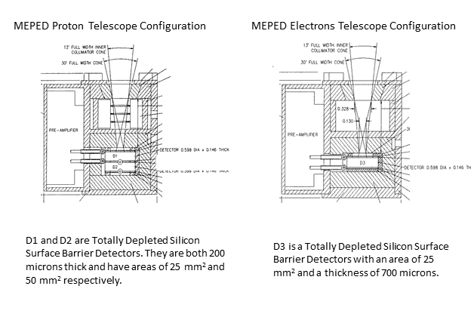
Figure 2-1: Schematics showing the MEPED proton telescopes (left) and electron telescopes (right)
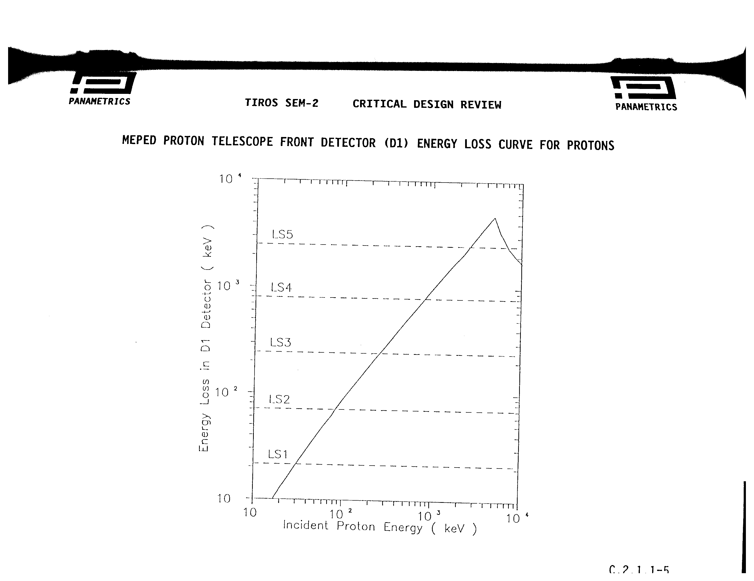
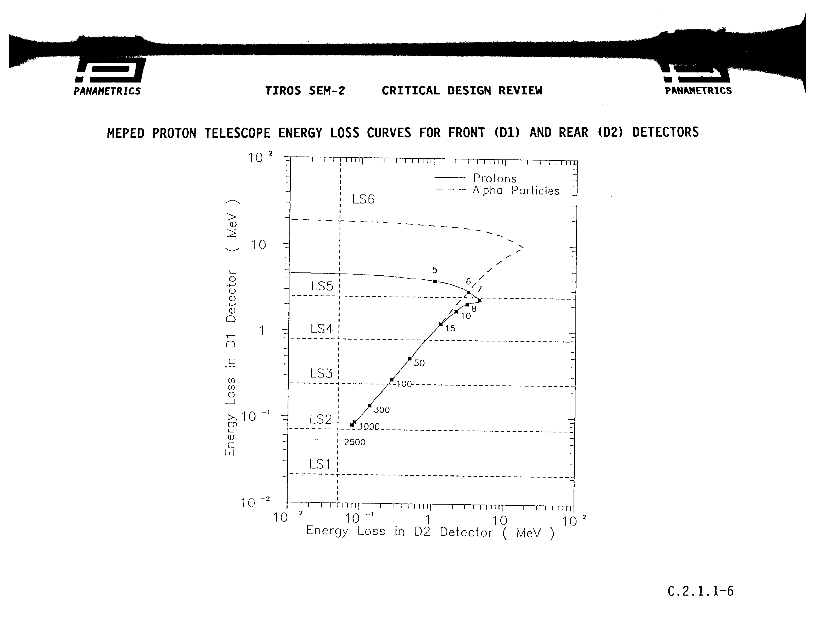
Figure 2-2 shows the response of the first (D1) proton detector to incoming protons along with voltage discriminator levels (LS1-LS5) and Figure 2-3 shows the energy loss of particles in the D2 detector. The particles are binned into 6 energy bands by applying logic to discriminator thresholds triggered by the incoming particle. Table 2-1 shows the exact discriminator thresholds and table 2-2 shows the logic applied. To illustrate the process, consider the response of the instrument to protons in the first energy band P1 (30 to 80 keV). Figure 2-3 shows that all protons with energy > 30 keV will trigger the LS1 threshold in the first detector. Thus to create a 30-100 keV proton channel the logic requires that LS1 be trigger but not LS2. Additionally, the logic requires that LS6 not be triggered to eliminate counting very energetic protons (>2500 keV). These energetic particles deposit little energy in the first detector as they pass through so they would still trigger L1 and not L2. However, they also trigger the LS6 threshold in the D2 detector. The electron response in the proton detectors are not explicitly called out here. (For more information see Yando et al. [2012])
Figure 2-2 Energy deposited by protons in the proton telescope front D1 detector
Figure 2-3 Energy deposited by protons in the proton telescope rear D2 detector

Table 2-1: Discriminator level thresholds for the proton detectors
Front Detector | (D1)
Level | Value (keV) | Proton energy range (keV)
LS1 | 21.4 | >30
LS2 | 70.7 | >80
LS3 | 243 | 250-150,000
LS4 | 796 | 800-36,000
LS5 | 2498 | 2,500-6,900
Rear Detector | (D2)
LS6 | 50 keV | >4800

Table 2-2: Proton telescope logic
Proton Channels | Logic | Proton Energy range
0P1/90P1 | $$1⋅\bar{2}⋅\bar{6}$$ | 30-80
0P2/90P2 | $$1⋅2⋅\bar{3}⋅\bar{6}$$ | 80-250
0P3/90P3 | $$1⋅3⋅\bar{4}⋅\bar{6}$$ | 250-800
0P4/90P4 | $$1⋅4⋅\bar{5}⋅\bar{6}$$ | 800-2500
OP5/90P5 | $$1⋅5$$ | 2500-6900
0P6/90P6 | $$1⋅\bar{5}⋅6$$ | >6900

The same type of process applies to the electron telescopes but with the response curves shown in figure 2-4, and the thresholds and logic given in tables 2-3 and 2-4. Here the expected response to protons is also provided. The electron response is not as straightforward as the proton response because of the smaller mass and tendency to scatter. An electron at a given energy may deposit energy anywhere between the curves labeled Stopping Electrons and Total Energy Loss.
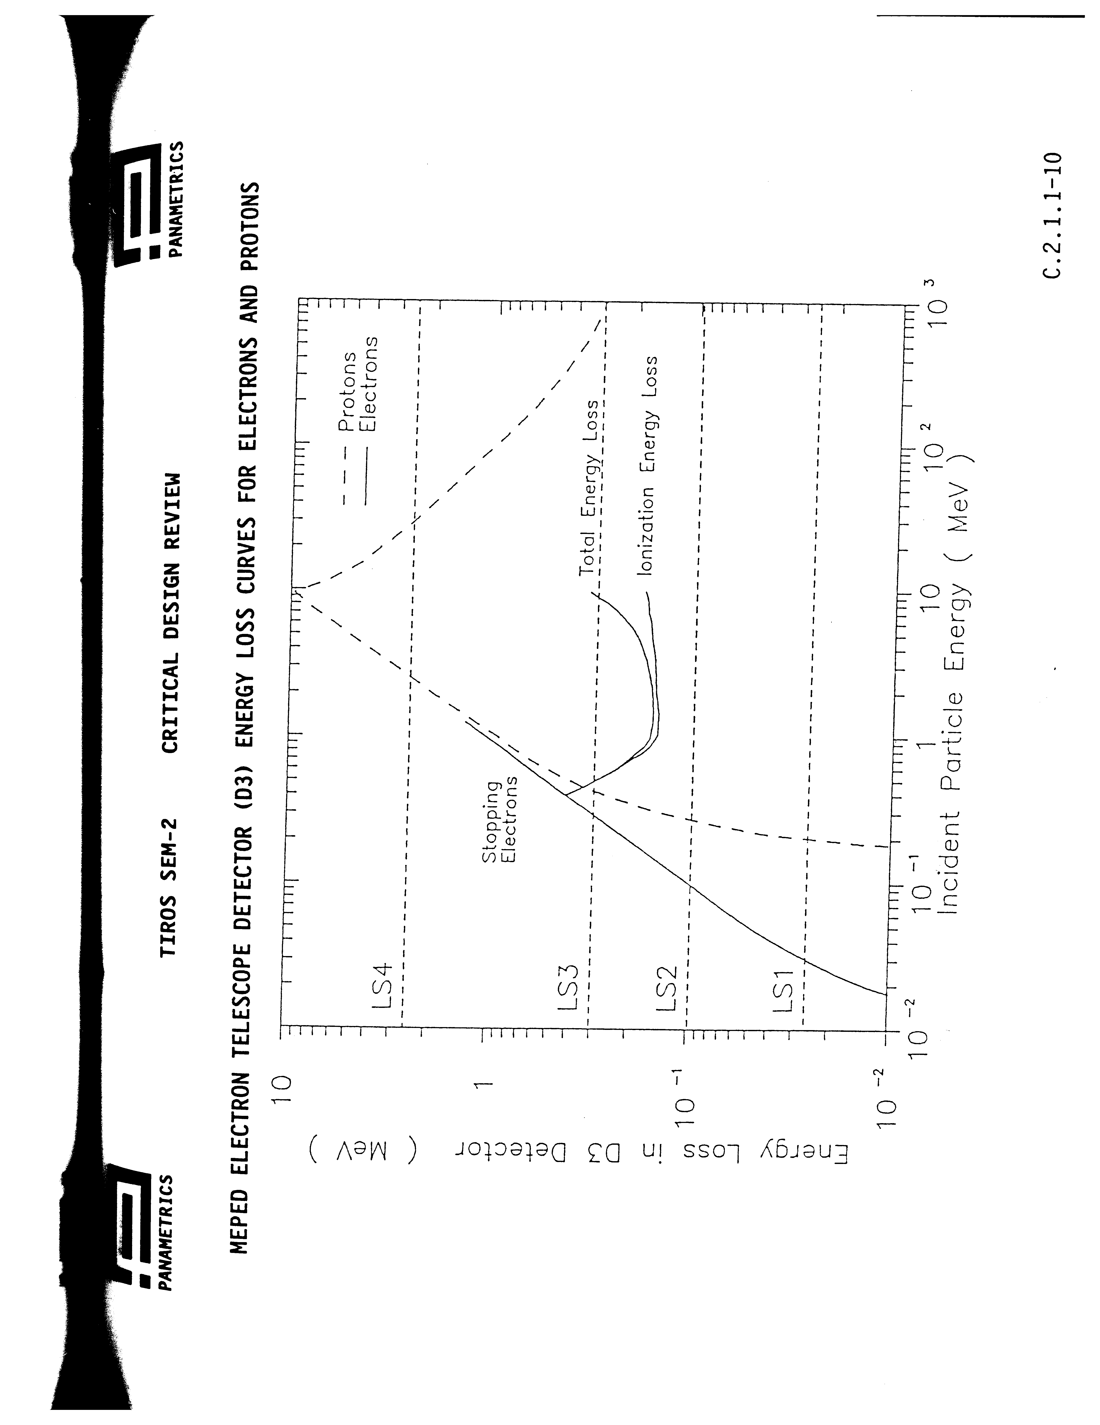
Figure 2-4: Energy loss for electrons and protons in the electron telescope detectors

Table 2-3 Discriminator Thresholds for the Electron Detectors
D3 Detector
Level | Value (keV) | Electron energy range (keV) | Proton Energy Range (keV)
LS1 | 25.6 | >30 | >210
LS2 | 98.1 | >80 | >280
LS3 | 299 | 250-150,000 | 440-1000000
LS4 | 2500 | - | 2700-30000

Table 2-4 Logic for the Electron Detectors
Electron Channels | Logic | Electron range (keV) | Proton range (keV)
0E1/90E1 | $$1⋅\bar{4}$$ | >30 keV | 210-280*
0E2/90E2 | $$1⋅2⋅\bar{4}$$ | >100 keV | 280-440*
0E3/90E3 | $$1⋅3⋅\bar{4}$$ | >300 keV | 440-2700*
*Only the low energy part of the proton range is listed. The higher energy range (>30 MeV) also has an omnidirectional component.

2.2.3 Sampling the directional flux

Two telescopes per species measure differences in the directional flux. The two telescopes are oriented such that one samples particles moving nearly along magnetic field lines and one samples nearly perpendicular to the magnetic field. The reason for this orientation is to monitor 2 different impacts from the particles: the effect on the atmosphere below the satellite and the effects within the magnetosphere above the satellite. The particles moving along the magnetic field lines will eventually impact the atmosphere where they can affect atmospheric chemistry and the production of NOx and ozone which in turn changes global circulation patterns and climate. The particles moving 90 degrees to the magnetic field at the satellite will bounce back and forth between the polar regions. Measuring the flux of these particles provides a global view of the space radiation environment that can damage satellites orbiting near Earth. Thus, two telescopes are oriented nearly along the zenith direction with one measuring proton flux and one measuring electron flux. At high latitudes where the particle flux is most significant, the zenith direction is nearly aligned with the magnetic field. The other two telescopes are oriented 90 degrees to the zenith direction with one measuring protons and one measuring electrons.

There are slight variations in the exact pointing of the POES and METOP telescopes. Figure 2-5 shows the alignment of the MEPED telescopes on the POES satellites. Here the X axis points earthward, the Y axis points opposite the velocity direction, and the Z axis completes the right hand set. In this coordinate system, the instruments are first placed such that the 0 degree detector is along the –X direction pointing away from Earth and the 90 degree detector is along the +Y direction opposite the satellite velocity direction. Next they are rotated 9 degrees about the Y axis (-X axis direction move 9 degrees towards the –Z direction). A second rotation of 9.08 degrees is then made about the original X axis (+Y axis direction moves 9.08 degrees toward the –Z direction). The MEPEDs on the MetOp satellites have no rotations. For these satellites, the 0 degree detector is aligned along the -X direction and the 90 degree sensor is aligned along the +Y direction.
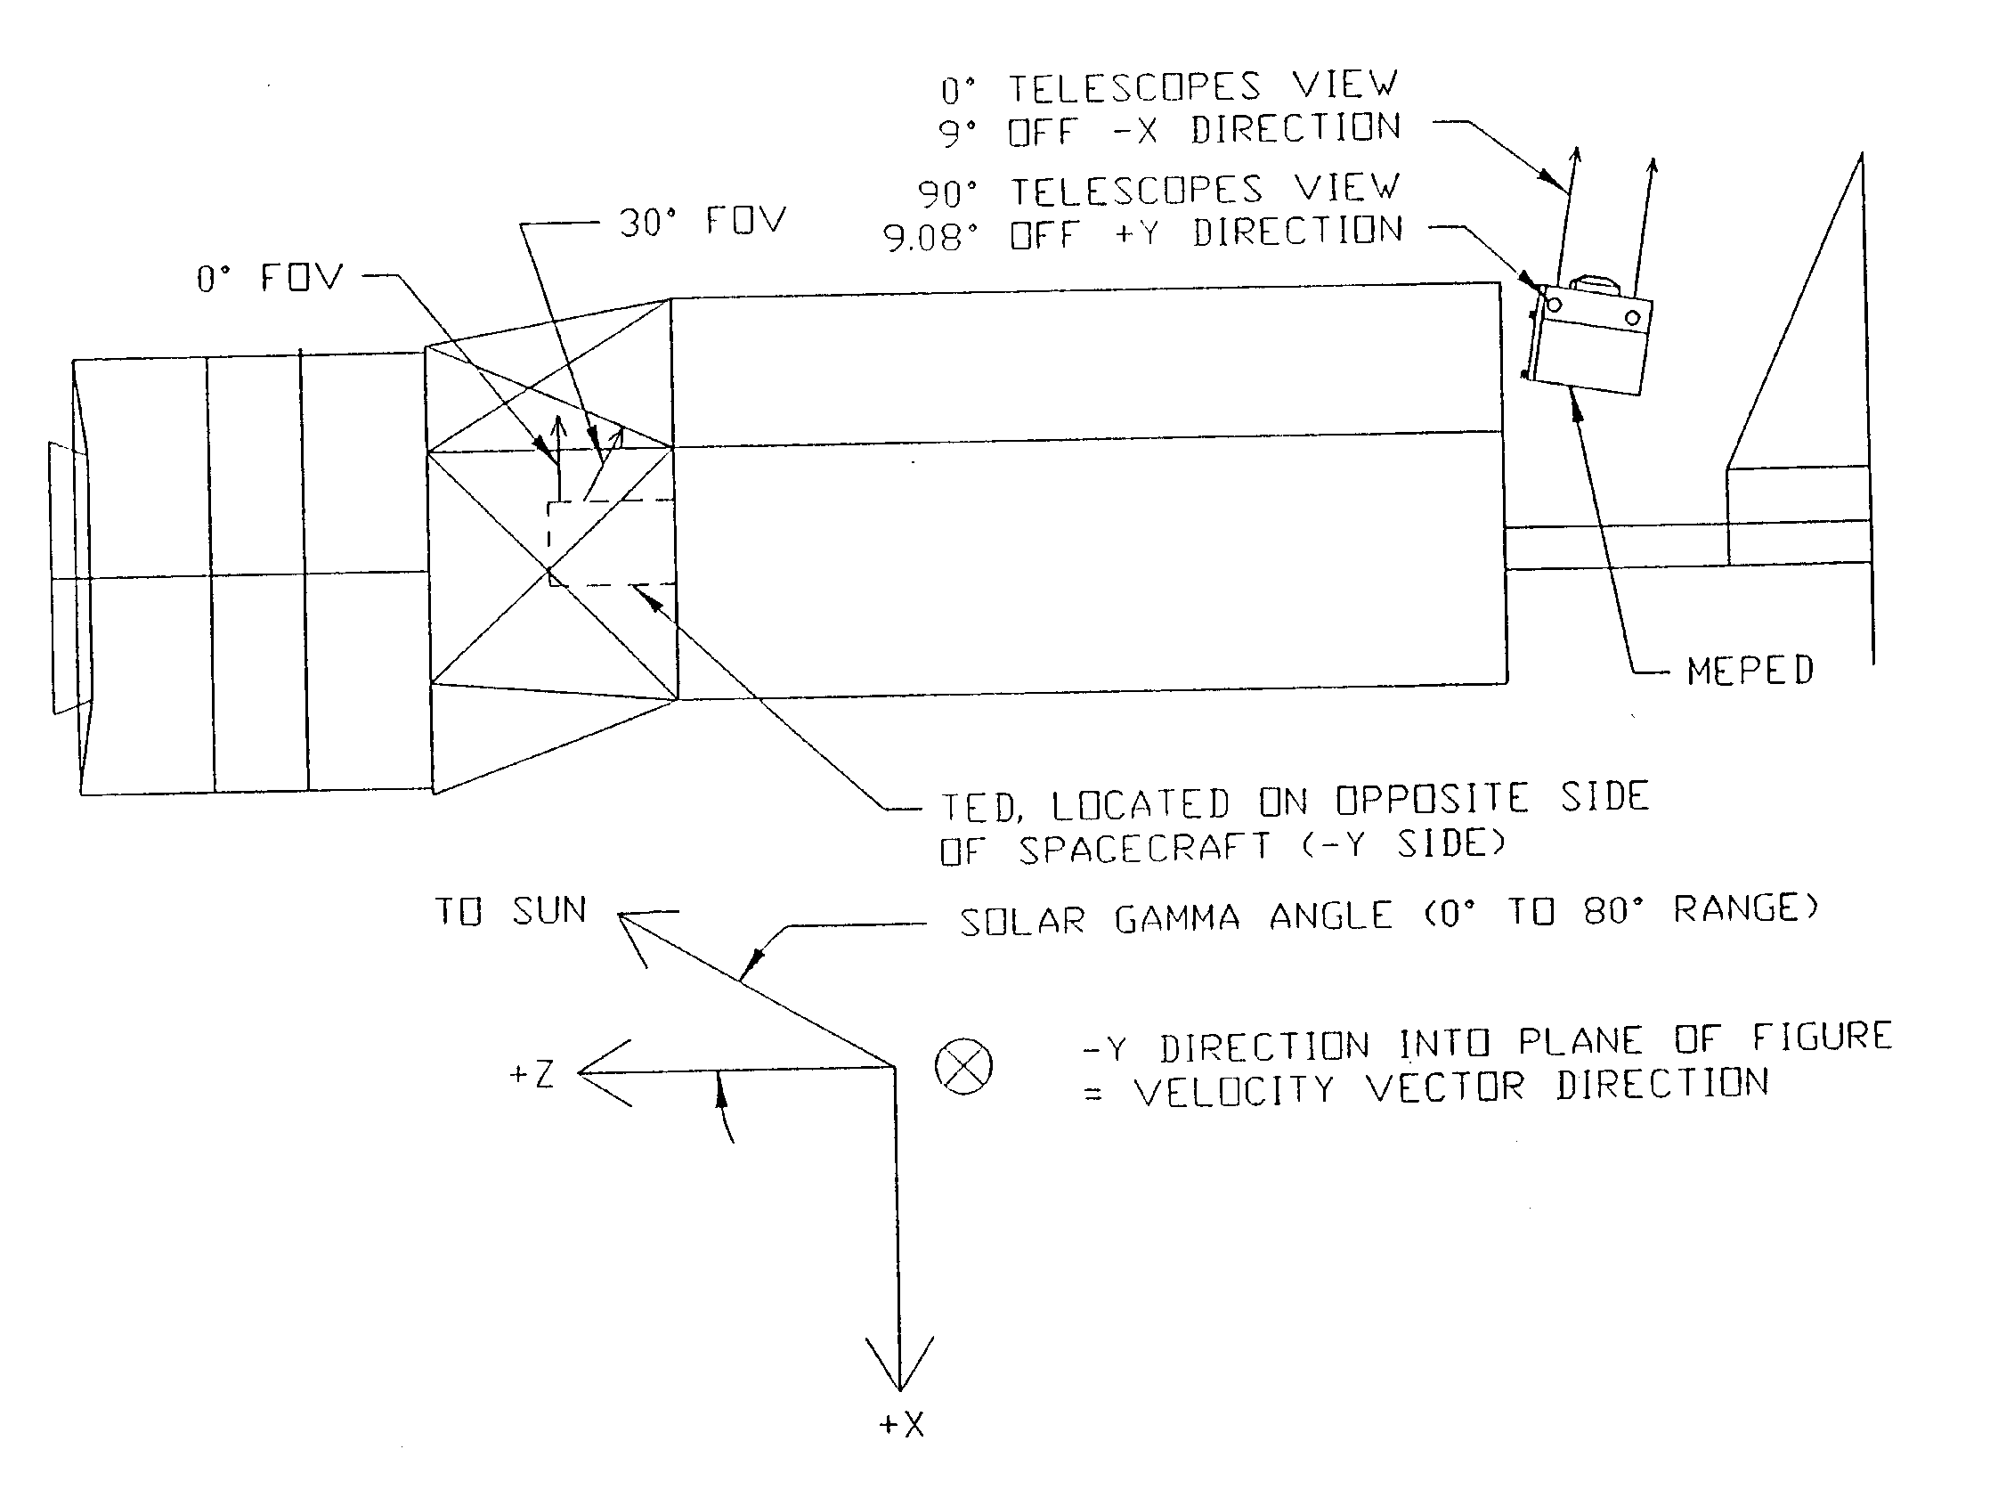
Figure 2-5 Alignment of the MEPED telescopes on the POES satellites

3.0 ALGORITHM DESCRIPTION

3.1 Algorithm Overview
The purpose of the MEPED telescope processing algorithm is to change the instrument counts to physical differential flux numbers as detailed in the outline below.

Processing Outline
These are the basic steps to take the MEPED telescope output to differential flux:

- Read the level1-b file and calibration tables
- Take the ones complement of the sensor data
- Decompress data to raw counts
- Check for backwards times and resort
- Change counts to physical units using calibration table values
- Calculate pitch angles at the satellite
- Calculate errors

3.3 Algorithm Input
The inputs to the algorithm consist of the sensor data, calibration tables, and International Geomagnetic Reference Field (IGRF) coefficient tables.

3.3.1 Primary Sensor Data

Table 3-1. L1b MEPED sensor data input to level 2 processing
L1b Quantity | Sampling | Number of Values | Units | Purpose in L2 Calculations
Compressed electron counts | 2s | 6 channels  (3 energy bands and 2 directions) | Compressed counts | Starting point for electron differential number flux
Compressed proton counts | 2s | 12 channels  (6 energy bands and 2 directions) | Compressed counts | Starting point for proton differential number flux

3.3.2 Ancillary Data
Ancillary data are defined as data that are not generated on-orbit by MEPED or the spacecraft. The MEPED telescope data processing requires 2 types of ancillary data: calibration data and magnetic field data.

3.3.2.1 Calibration data

This section describes the calibration data as well as the detailed method for creating that data. The calibration data referred to here are a table of values by which the raw sensor data is multiplied to translate the number of particles counted in each energy channel to physical flux units. These calibration values are obtained using the bow tie method. We describe how the method is used to define the differential flux (#/cm2-s-str-keV) for the first 5 proton channels as well as the integral flux (#/cm2-s-str) for the electron channels and the last proton channel.

The goal of the bow tie method is to find a single calibration value that will change sensor counts to flux with the smallest error given that the spectral shape of the flux entering the detector is unknown and always changing. The search for those calibration values begins with a simple definition of the counts measured within an energy channel over an integration time step (in the case of the MEPED telescopes time integration is 1 s):

${\text{counts}}_{\text{chan}}=\int_{0}^{Ω}{}\int_{0}^{A}{}\int_{0}^{∞}{\text{eff}(E)J(E)\text{dEdAd}Ω}=AΩ\int_{0}^{∞}{\text{eff}(E)J(E)\text{dE}}$.

Here counts_{chan} is the number of particles measured within a single energy channel, eff(E) is the efficiency for measuring particles of different energies, J(E) is the differential particle flux (#/cm2-s-str-keV) as a function of energy, E is energy, A is the area of the detector and Ω is the solid angle subtended by the detector opening. (An implicit assumption is that the flux J does not vary with angle across the opening of the detector which for the MEPED detectors is 30 degrees). Most often the efficiency, the area of the detector, and the solid angle are subsumed into a single value for convenience that we refer to here as the geometric factor response function such that
$${\text{counts}}_{\text{chann}}=\int_{0}^{∞}{G(E)J(E)\text{dE}}$$
where G(E) now has units of cm²-str. As an example, Figure 3-1 shows the measured response functions for electrons impacting the 3 electron channels experimentally determined by placing the instrument in a test beam. The measured response functions for protons impacting the electron detectors as well as the responses in the proton detectors are given in Appendix C.

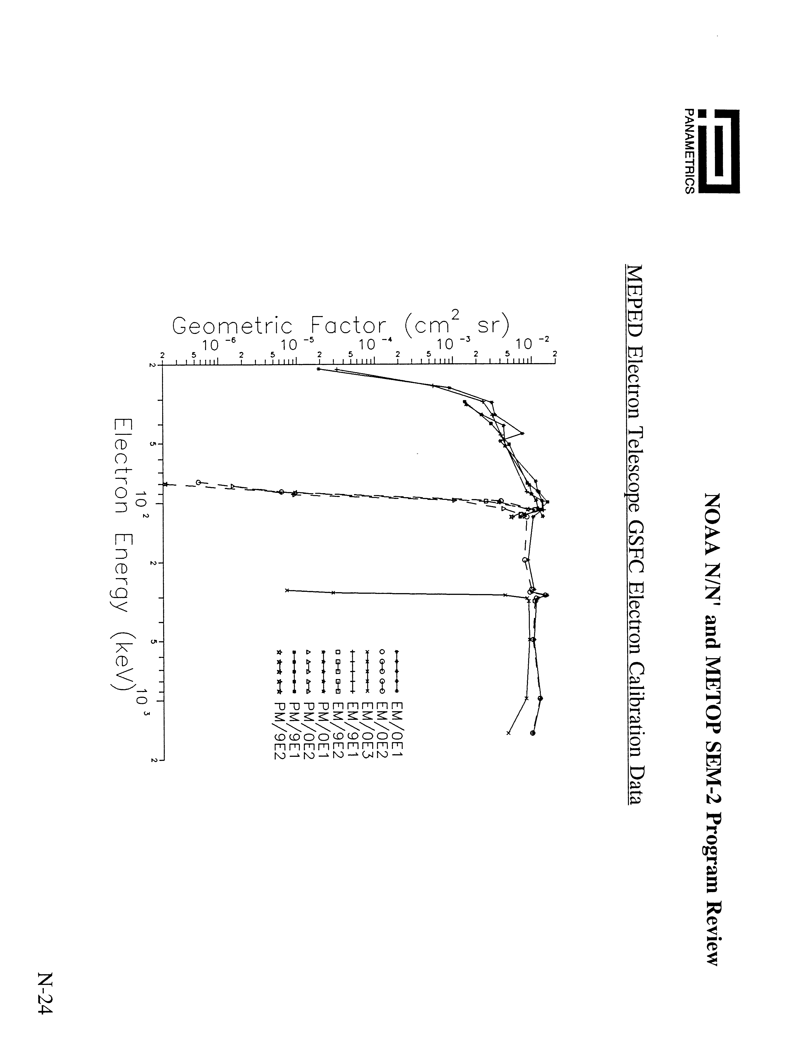
Figure 3-1Meaured response functions for the electron 0 and 90 degree telescopes

The differential flux, J(E), is now the unknown value to solve for. For the proton differential flux channels, the flux variation with energy within a given energy band is small enough that the following approximation is reasonable:
$${\text{counts}}_{\text{chann}}=\int_{0}^{∞}{G(E)J(E)\text{dE}}=\bar{G}J(\tilde{E})δE=G_{\text{final}}J(\tilde{E})$$
The goal is now to find appropriate values of G_{final} and $\tilde{E}$. Those values are determined by assuming a functional form of the flux such as J(E)=exp(-E/E0) or J(E)=E^{-γ}. The geometric response function G(E) can be measured or determined by modeling. In this case, we use the response function from Yando et al [2012] modeled with GEANT rather than the measured response functions because they are more complete. Now the equations can be solved for G_{final} assuming different values of E0 and $\tilde{E}$ or and γ and $\tilde{E}$ such that
$$\frac{\int_{0}^{∞}{G(E)\text{exp}(−E/E0)\text{dE}}}{\text{exp}(−{\tilde{E}}/E0)}=G_{\text{final}}$$

or

$$\frac{\int_{0}^{∞}{G(E)E^{−γ}\text{dE}}}{{\tilde{E}}^{−γ}}=G_{\text{final}}$$

In our analysis we consider both exponential and power law forms. Figure 3-2 shows the results from all possible solutions for the 5 differential proton channels. (The figure resembles a bow-tie hence the name of the method). 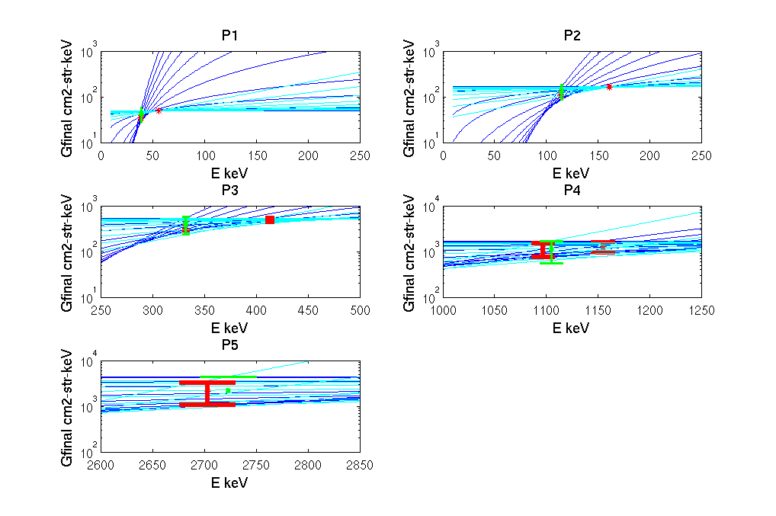
Figure 3-2 Bow tie curves for the proton telescopes energy channels p1 through p5. Dark blue lines show the traces assuming an exponential flux. Cyan lines the traces assuming a power law flux form. Red bars show the point with the minimum G spread for the exponential and power law form. Green shows the point with the minimum G spread obtained when considering both.

The final value of G is obtained by choosing a value of $\tilde{E}$ with the smallest spread in the possible G for all spectral shapes. The results are given in table 3-2.

For the electron channels and the highest energy proton channels the technique is modified slightly. The energy width is large enough that the above approximation is not valid. Here we assume instead that:

$${\text{counts}}_{\text{chann}}=\int_{0}^{∞}{G(E)J(E)\text{dE}}=G_{\text{final}}\int_{E\text{min}}^{∞}{J(E)\text{dE}}$$

Solving for Gfinal gives:

$$\frac{\int_{0}^{∞}{G(E)\text{exp}(−E/E0)\text{dE}}}{\int_{E}^{∞}{}\text{exp}(−E/E0)\text{dE}}=G_{\text{final}}$$
and

$$\frac{\int_{0}^{∞}{G(E)E^{−γ}\text{dE}}}{\int_{E}^{∞}{}E^{−γ}\text{dE}}=G_{\text{final}}$$

Figure 3-3 shows the bow ties for the electron channels. The final values of Gfinal and E with the least spread are given in table 3-2. To turn counts to flux multiply by Gfinal .
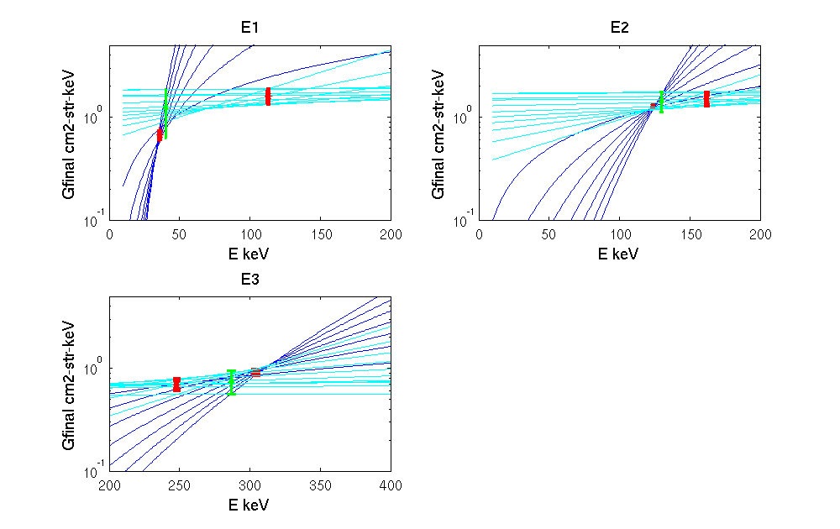
Figure 3-3: Bow ties for the electron channels.

Table 3-2 Geometric factors and center energies for proton and electron curves from the bow tie analysis
Proton channel | Energy (keV) | Gfinal | +/-dG
P1 | 39 | 100/42.95 (cm2-s-str-keV)⁻¹ | 100/14.97
P2 | 115 | 100/135.28 (cm2-s-str-keV)⁻¹ | 100/47.43
P3 | 332 | 100/401.09 (cm2-s-str-keV)⁻¹ | 100/167.50
P4 | 1105 | 100/1128.67 (cm2-s-str-keV)⁻¹ | 100/573.42
P5 | 2723 | 100/2202.93 (cm2-s-str-keV)⁻¹ | 100/2243.53
P6 | 6423 | 100/.41 (cm2-s-str)⁻¹ | 100/.18
Electron Channel | Energy (keV) | Gfinal (cm2-s-str)⁻¹ | +/-dG
E1 | 40 | 100/1.24 | 100/.62
E2 | 130 | 100/1.44 | 100/.32
E3 | 287 | 100/.75 | 100/.19
E4 | 612 | 100/.55 | 100/.40

3.3.2.2 Magnetic field data

The magnetic field ancillary data is contained in ascii tables that provide the coefficients for expanding Earth’s internal field as spherical harmonics. These tables are used to predict the magnetic field at the satellite location because there is no magnetometer onboard to provide that measurement. The magnetic field is critical for determining how the particle measurements relate to the field direction and which particles are expected to continue along the field lines to the atmosphere. Due to some legacy code being used in the processing, the IGRF coefficients are duplicated in several files. The file called igrf11coefficients.txt contains all the igrf data from 1900 to 2010 at five year intervals. This file must be updated at regular 5 year intervals. Additionally, the igrf coefficients are also contained in individual 5 year files (dgrf00.dat, dgrf05.dat, igrf05.dat, and igrf00.dat). These will need to be updated every 5 years as well and supplemented to reprocess any older data prior to 2000. The IGRF coefficients can be obtained from http://www.ngdc.noaa.gov/IAGA/vmod/igrf.html.

3.4 Processing Procedure
This section describes the processing outline in greater detail.

3.4.1 Read the Level-1B files and Calibration Tables
Data from the POES/MetOp satellites are downloaded from the satellites generally once per orbit to a number of ground stations (Wallops Island, VA; Gilmore Creek, AK; McMurdo,Antartica; Svalbard, Norway). The raw telemetry is deciphered and packaged into level1-B files specific to each instrument at NSOF in Silver Springs MD where they are distributed via the Data Distribution System. A single level1b file is produced for the entire SEM-2 instrument suite. The NGDC processing system checks the DDS system for new data every 2 minutes and pulls any new files to NOAA NGDC for processing. The format of these data files and additional description of the telemetry is described in Appendix D. The ancillary calibration and magnetic field tables are maintained at NGDC as static ascii files and are read every time a file is processed. The calibration coefficients are independent of the satellite.

3.4.2 Take the ones complement of the sensor data
The output from the MEPED instrument is given as single bytes. For an unknown reason, the instrument puts out information as the ones complement of normal binary. The first processing step is to swap all the 1’s and 0’s of the sensor output.

3.4.3 Decompress data to raw counts
The particle energy flux data are compressed to values between 0 and 255 in order to fit into a single 8 bit value. These values are decompressed into counts using a static look up table given in Appendix A table A-1.

3.4.4 Calculate magnetic parameters needed to map to the ionosphere
Knowledge of the magnetic field is necessary to determine which particles will be guided by the magnetic field such that they are absorbed by the atmosphere. The processing determines the local magnetic field at the satellite, traces that filed line to the atmosphere at 110 km and then calculates the magnetic field at the atmosphere. The calculations are done using the IGRF coefficients for the internal magnetic field.

3.4.5 Check for backwards times and resort
Once all the data has been read, the processing checks to see that the data are ordered correctly by time. Frequently, times are repeated in the level1-B files because the telemetry download from the satellites was stopped, backed up, and then restarted. Any duplicate times are replaced with data records appearing earlier in the file replaced by later data records.

3.4.8 Change counts to physical units using a calibration table
Changing the sensor counts to physical units is a simple multiplication by a constant calibration factor. The bow-tie method is used to determine the calibration factors as explained in great detail in section 3.3.2.1. Although the instrument is designed to measure 6 proton channels and 3 electron channels for each of the two look directions the processing puts out one additional electron channel labeled e4. Here the e4 channel is the electron flux measured by the p6 channel. To produce this channel the p6 counts are multiplied by a calibration coefficient determined from the telescope response to electrons. A check is done to ensure that the counts are truly electrons and not protons. Typically, if protons are present there will be a measureable signal in the p5 channel as well. The processing checks to see if the counts in the p5 channel are less than 3. If the counts are greater than 3 then the e4 output is flagged to -999.

3.4.9 Calculate pitch angles at the satellite and at the foot of the field line

Calculating the pitch angle at the satellite requires knowing the orientation of the sensors and the magnetic field in the same coordinate system. The processing relies on the spacecraft coordinates defined with Bx radially Earthward, By in the direction opposite the velocity of the satellite, and Bz completes the right hand set (BxXBy). In this coordinate system, detectors are aligned as described in section 2.2.3.

The magnetic field parameters are first determined in the geodetic reference frame using the IGRF spherical harmonic expansion and then rotated into the spacecraft frame. The spacecraft coordinates are defined for every 2 second measurements as follows. First, the radial spacecraft x direction is defined by the latitude and longitude provided in the level 1 B file.

$$\begin{aligned}X1=\text{sin}(\text{90}−\text{latitude})\text{cos}(\text{longitude}) \\ X2=\text{sin}(\text{90}−\text{latitude})\text{sin}(\text{longitude}) \\ X3=\text{cos}(\text{90}−\text{latitude}) \\ {\vec{X}}_{\text{sc}}=[X1,X2,X3]\end{aligned}$$

The spacecraft z component, Zsc, is determined from the cross product of these vectors for 2 subsequent times where first refers to the point earlier in time and last refers to the point later in time.

$$\begin{aligned}Z1=X2\text{last}∗X3\text{first}−X3\text{last}∗X2\text{first} \\ Z2=X3\text{last}∗X1\text{first}−X1\text{first}∗X3\text{last} \\ Z3=X1\text{last}∗X2\text{first}−X2\text{last}∗X1\text{first} \\ {\vec{Z}}_{\text{sc}}=−[Z1,Z2,Z3]\end{aligned}$$

Next the ram direction or –y direction is defined as the cross product of z and the x direction defined above. The B field in spacecraft coordinates is defined by:
$\begin{aligned}{\text{Bx}}_{\text{sc}}=\vec{B}⋅{\vec{X}}_{\text{sc}} \\ {\text{By}}_{\text{sc}}=\vec{B}⋅{\vec{Y}}_{\text{sc}} \\ {\text{Bz}}_{\text{sc}}=\vec{B}⋅{\vec{Z}}_{\text{sc}}\end{aligned}$

Finally, the pitch angle directions are defined by taking the dot product of Bsc with the negative of the detector direction. This is because the particle entering the detector is moving in the direction opposite to the look direction.

At the foot of the field line the pitch angle is determined by assuming that the first invariant, μ=Wperp/B, and the total energy of the particle is conserved. In this case,

$$\begin{aligned}W_{\text{perp}=}W{\text{sin}}^{2}α \\ μ={W_{\text{perp}}}/B \\ α_{\text{foot}}=a\text{sin}{\left(\frac{B_{\text{foot}}{\text{sin}}^{2}α}{B_{\text{local}}}\right)}^{\frac{1}{2}}\end{aligned}$$

3.4.11 Error calculations
Lastly, the algorithm calculates errors for all physical quantities. Here the error due to Poisson counting statistics and the error in the calibration coefficients are included. The Poisson errors do to counting statistics are given as +/-sqrt(N) where N is the count value. Standard error propagation is used to combine the calibration errors and the Poisson errors.

3.5 Algorithm Output

The algorithm outputs are given in Appendix B Table B-1 that includes all outputs from the TED, MEPED telescope, and MEPED omnidirectional processing algorithms. These outputs are divided into two files: raw and processed. The second column of the table gives a single letter that identifies which file the element is in. Those labeled ‘a’ are in all files, those labeled ‘p’ are in the processed files, and those labeled ‘r’ are in the raw files.

4.0 TESTING THE ALGORITHM PERFORMANCE
There are two objectives to testing the performance of the MEPED data processing algorithms. The first objective is to ensure that there are no flaws in the method or implementation of the algorithms. This objective is met by simply comparing the output to that from the legacy processing. The results of the comparison are discussed in section 4.2. The second objective is to provide users with an assessment of the accuracy of the output data. Several accuracy indicators should be considered when using the data. Uncertainty values estimated from poisson counting statistics are provided with all physical quantities. Other factors not considered here that may significantly affect performance are the intercalibration of the satellites, the degradation of the sensors, and cross species contamination. These additional factors are discussed further in section 6.1 but accounting for these issues is beyond the scope of the current processing level. Users should consider how these limitations in the data accuracy might impact their use or interpretation of the data.

4.1 Input Data Sets
The legacy files used to compare to the new processing are the full resolution daily binary archive fails produced by NOAA SWPC up until Jan 2013 and archived at NGDC. The contents of the files are described by Greer and Evans [2000].

4.2 Comparisons of Test Data and Algorithm Output
To ensure that there are no fundamental flaws in the new processing we compare all values contained in the legacy archive files to the newly processed files for the same time periods. Both files are produced from the same L1B input files. In some cases, the outputs from two processes should be exactly the same because the algorithms used by both are identical. For example, both systems produce counts from the same simple look-up table translation. In these cases, our comparisons show no difference demonstrating no issues with the new implementation. In other cases, the outputs may be different because of small difference in the methods. Therefore, we focus our attention on comparing these values. The outputs that fall into this category are the magnetic field parameter outputs.

The magnetic field parameters from both systems are generated using the same IGRF field model however, the implementation is slightly different. The legacy software relied on static files of the IGRF field model as a function of latitude and longitude that were updated once per year. The new processing calls the IGRF field model for every 2 second data record and provides a more up-to-date representation. Figure 4-1 shows a comparison of the magnetic field parameters from the two systems for one orbit on Jan 27, 2012 (blue trace is the legacy output and red trace is the new output). The plot shows virtually no difference in the field components. Figure 4-2 shows a comparison of the pitch angle measured by the 90 and 0 degree detectors at the location of the satellite and mapped to the atmosphere. The local pitch angles differ by ~5 degrees at most. However, these differences occur near the equator in regions where the MEPED instrument is not expected to measure any particle fluxes. Thus, the differences do not have a big impact on the data interpretation. Figure 4-3 shows the location where the field lines map to the atmosphere in different coordinates: geographic, magnetic, and corrected geomagnetic coordinates. The only quantity that differs significantly is the magnetic longitude. Here the new processing provides the magnetic longitude of the field line at the equator.

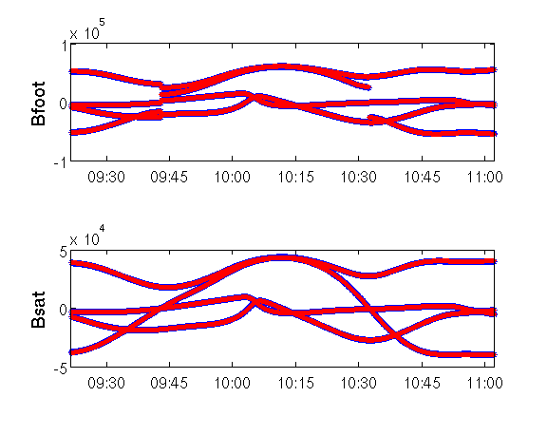
Figure 4-1 Comparison of legacy and new magnetic field components. Legacy values are shown in blue and new values are shown in red.

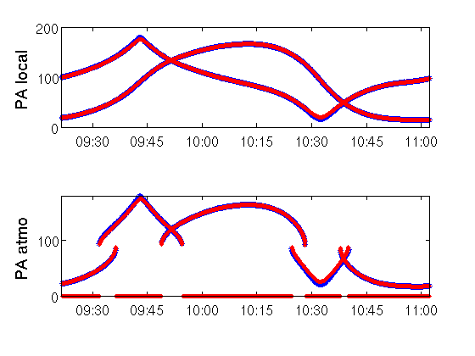
Figure 4-2 Comparison of legacy and new pitch angles at the satellite location (top panel) and at the atmosphere (bottom panel). Legacy values are shown in blue and new values are shown in red.
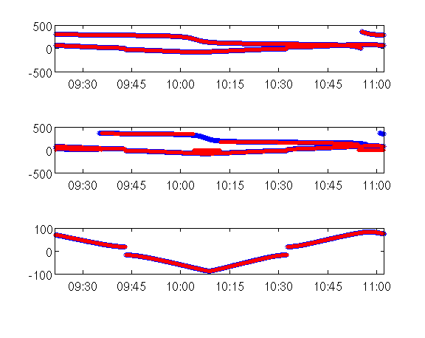
Figure 4-3 Comparison between legacy and new processing outputs of the location of the foot of the field line.

5.0 PRACTICAL CONSIDERATIONS

5.1 Numerical Computation Considerations
The algorithm is straightforward to implement in software and does not require special considerations for computing power.

5.2 Programming and Procedural Considerations
The operational algorithm has been implemented in C++ and fortran with a groovy wrapper.

5.3 Quality Assessment and Diagnostics

Quality assessment of the operational product should be based on the error bars provided in the datafiles.

5.5 Algorithm Validation
An additional Possibility for validating the algorithm and the data would be to compare to additional datasets. One possibility would be to compare to the SAMPEX data. However, differences in the look directions, energies, and altitudes makes such a comparison challenging and is beyond the scope of the current work.

6.0 ASSUMPTIONS AND LIMITATIONS

6.1 Performance
The algorithm provides error bars to describe performance. However, these errors only include those due to Poisson counting statistics and the bow-tie calibration factor. Other sources of error such as instrument degradation, cross species contamination and satellite intercalibration differences are not considered.

Degradation of the sensors is possibly a significant source of error that is more likely to affect the proton sensors. The possibility has been raised that over a time a dead layer is created due to accumulated particle impacts. The dead layer has the effect of decreasing the energy deposited by a passing particle such that higher energy particles appear as lower energy particles. The effect shifts the energy bands to higher energies typically leading to a slow decrease in the measured fluxes. This phenomenon is difficult to discern because other differences such as changes in the satellite orbit can cause a similar effect. Thus, this degradation has not been well quantified and is not included in the processing.

Cross species contamination is most certainly a significant source of error. The most noticeable effect is the electrons measured in the P6 channel and the protons measured in the E3 channel. In theory, the proton and electron measurements could be inverted together to provide uncontaminated estimates. However, the inversion technique may sometimes give unphysical results. This utility of this method for routine processing is still being investigated.

Lastly, there may be differences between the data from different satellites because of variations in the orbits or other factors. Intercalibration of the data is beyond the scope of this work.

6.2 Assumed Sensor Performance

NA

6.3 Pre-Planned Product Improvements
None at this time.

REFERENCES

Yando, Karl; Millan, Robyn M.; Green, Janet C.; Evans, David S., A Monte Carlo simulation of the NOAA POES Medium Energy Proton and Electron Detector instrument, J. Geophys. Res., Volume 116, Issue A10, CiteID A10231

Appendix A: Data Tables

Table A-1 Data Decompression Look-up Table
Conversion table= (0.0,1.0,2.0,3.0,4.0,5.0,6.0,7.0,8.0,9.0,10.0,11.0,12.0,13.0,14.0,15.0,16.0,17.0,18.0,19.0,20.0,21.0,22.0,23.0,24.0,25.0,26.0,27.0,28.0,29.0,30.0,31.0,32.0,34.5,36.5,38.5,40.5,42.5,44.5,46.5,48.5,50.5,53.0,56.0,59.0,62.0,65.5,69.5,73.5,77.5,81.5,85.5,89.5,93.5,97.5,101.5,106.5,112.5,118.5,124.5,131.5,139.5,147.5,155.5,163.5,171.5,179.5,187.5,195.5,203.5,213.5,225.5,237.5,249.5,263.5,279.5,295.5,311.5,327.5,343.5,359.5,375.5,391.5,407.5,427.5,451.5,475.5,499.5,527.5,559.5,591.5,623.5,655.5,687.5,719.5,751.5,783.5,815.5,855.5,903.5,951.5,999.5,1055.5,1119.5,1183.5,1247.5,1311.5,1375.5,1439.5,1503.5,1567.5,1631.5,1711.5,1807.5,1903.5,1999.5,2111.5,2239.5,2367.5,2495.5,2623.5,2751.5,2879.5,3007.5,3135.5,3263.5,3423.5,3615.5,3807.5,3999.5,4223.5,4479.5,4735.5,4991.5,5247.5,5503.5,5759.5,6015.5,6271.5,6527.5,6847.5,7231.5,7615.5,7999.5,8447.5,8959.5,9471.5,9983.5,10495.5,11007.5,11519.5,12031.5,12543.5,13055.5,13695.5,14463.5,15231.5,15999.5,16895.5,17919.5,18943.5,19967.5,20991.5,22015.5,23039.5,24063.5,25087.5,26111.5,27391.5,28927.5,30463.5,31999.5,33791.5,35839.5,37887.5,39935.5,41983.5,44031.5,46079.5,48127.5,50175.5,52223.5,54783.5,57855.5,60927.5,63999.5,67583.5,71679.5,75775.5,79871.5,83967.5,88063.5,92159.5,96255.5,100351.5,104447.5,109567.5,115711.5,121855.5,127999.5,135167.5,143359.5,151551.5,159743.5,167935.5,176127.5,184319.5,192511.5,200703.5,208895.5,219135.5,231423.5,243711.5,255999.5,270335.5,286719.5,303103.5,319487.5,335871.5,352255.5,368639.5,385023.5,401407.5,417791.5,438271.5,462847.5,487423.5,511999.5,540671.5,573439.5,606207.5,638975.5,671743.5,704511.5,737279.5,770047.5,802815.5,835583.5,876543.5,925695.5,974847.5,1023999.5,1081343.5,1146879.5,1212415.5,1277951.5,1343487.5,1409023.5,1474559.5,1540095.5,1605631.5,1671167.5,1753087.5,1851391.5,1949695.5,1998848.0;)

Appendix B: Outputs

Table B-1: Processing Output
year | a | int | 4 | 1950 | 2050 | year
day | a | int | 3 | 0 | 366 | day
msec | a | int | 8 | 0 | 86400000 | millisec
satID | a | int | 2 | 0 |  | ID
minor_frame | r | int | 3 | 0 | 320 | frame
major_frame | r | int | 3 | 0 | 7 | frame
sat_direction | a | int | 1 | 0 | 1
alt | a | float | 7.3 | 800 | 1000 | km
lat | a | float | 7.3 | -90 | 90 | degrees
lon | a | float | 7.3 | 0 | 360 | degrees
mep_pro_tel0_cps_p1 | r | float | 9.1 | 0 | 1998848 | #/s
mep_pro_tel0_cps_p2 | r | float | 9.1 | 0 | 1998848 | #/s
mep_pro_tel0_cps_p3 | r | float | 9.1 | 0 | 1998848 | #/s
mep_pro_tel0_cps_p4 | r | float | 9.1 | 0 | 1998848 | #/s
mep_pro_tel0_cps_p5 | r | float | 9.1 | 0 | 1998848 | #/s
mep_pro_tel0_cps_p6 | r | float | 9.1 | 0 | 1998848 | #/s
mep_pro_tel90_cps_p1 | r | float | 9.1 | 0 | 1998848 | #/s
mep_pro_tel90_cps_p2 | r | float | 9.1 | 0 | 1998848 | #/s
mep_pro_tel90_cps_p3 | r | float | 9.1 | 0 | 1998848 | #/s
mep_pro_tel90_cps_p4 | r | float | 9.1 | 0 | 1998848 | #/s
mep_pro_tel90_cps_p5 | r | float | 9.1 | 0 | 1998848 | #/s
mep_pro_tel90_cps_p6 | r | float | 9.1 | 0 | 1998848 | #/s
mep_pro_tel0_flux_p1 | p | float | 14.5 | 0 |  | #/cm2-s-str-keV
mep_pro_tel0_flux_p2 | p | float | 14.5 | 0 |  | #/cm2-s-str-keV
mep_pro_tel0_flux_p3 | p | float | 14.5 | 0 |  | #/cm2-s-str-keV
mep_pro_tel0_flux_p4 | p | float | 14.5 | 0 |  | #/cm2-s-str-keV
mep_pro_tel0_flux_p5 | p | float | 14.5 | 0 |  | #/cm2-s-str-keV
mep_pro_tel0_flux_p6 | p | float | 14.5 | 0 |  | #/cm2-s-str-keV
mep_pro_tel0_flux_p1_err | p | float | 14.5 | 0 |  | #/cm2-s-str-keV
mep_pro_tel0_flux_p2_err | p | float | 14.5 | 0 |  | #/cm2-s-str-keV
mep_pro_tel0_flux_p3_err | p | float | 14.5 | 0 |  | #/cm2-s-str-keV
mep_pro_tel0_flux_p4_err | p | float | 14.5 | 0 |  | #/cm2-s-str-keV
mep_pro_tel0_flux_p5_err | p | float | 14.5 | 0 |  | #/cm2-s-str-keV
mep_pro_tel0_flux_p6_err | p | float | 14.5 | 0 |  | #/cm2-s-str-keV
mep_pro_tel90_flux_p1 | p | float | 14.5 | 0 |  | #/cm2-s-str-keV
mep_pro_tel90_flux_p2 | p | float | 14.5 | 0 |  | #/cm2-s-str-keV
mep_pro_tel90_flux_p3 | p | float | 14.5 | 0 |  | #/cm2-s-str-keV
mep_pro_tel90_flux_p4 | p | float | 14.5 | 0 |  | #/cm2-s-str-keV
mep_pro_tel90_flux_p5 | p | float | 14.5 | 0 |  | #/cm2-s-str-keV
mep_pro_tel90_flux_p6 | p | float | 14.5 | 0 |  | #/cm2-s-str-keV
mep_pro_tel90_flux_p1_err | p | float | 14.5 | 0 |  | #/cm2-s-str-keV
mep_pro_tel90_flux_p2_err | p | float | 14.5 | 0 |  | #/cm2-s-str-keV
mep_pro_tel90_flux_p3_err | p | float | 14.5 | 0 |  | #/cm2-s-str-keV
mep_pro_tel90_flux_p4_err | p | float | 14.5 | 0 |  | #/cm2-s-str-keV
mep_pro_tel90_flux_p5_err | p | float | 14.5 | 0 |  | #/cm2-s-str-keV
mep_pro_tel90_flux_p6_err | p | float | 14.5 | 0 |  | #/cm2-s-str-keV
mep_ele_tel0_cps_e1 | r | float | 9.1 | 0 | 1998848 | #/s
mep_ele_tel0_cps_e2 | r | float | 9.1 | 0 | 1998848 | #/s
mep_ele_tel0_cps_e3 | r | float | 9.1 | 0 | 1998848 | #/s
mep_ele_tel90_cps_e1 | r | float | 9.1 | 0 | 1998848 | #/s
mep_ele_tel90_cps_e2 | r | float | 9.1 | 0 | 1998848 | #/s
mep_ele_tel90_cps_e3 | r | float | 9.1 | 0 | 1998848 | #/s
mep_ele_tel0_flux_e1 | p | float | 14.5 | 0 |  | #/cm2-s-str
mep_ele_tel0_flux_e2 | p | float | 14.5 | 0 |  | #/cm2-s-str
mep_ele_tel0_flux_e3 | p | float | 14.5 | 0 |  | #/cm2-s-str
mep_ele_tel0_flux_e4 | p | float | 14.5 | 0 |  | #/cm2-s-str
mep_ele_tel0_flux_e1_err | p | float | 14.5 | 0 |  | #/cm2-s-str
mep_ele_tel0_flux_e2_err | p | float | 14.5 | 0 |  | #/cm2-s-str
mep_ele_tel0_flux_e3_err | p | float | 14.5 | 0 |  | #/cm2-s-str
mep_ele_tel0_flux_e4_err | p | float | 14.5 | 0 |  | #/cm2-s-str
mep_ele_tel90_flux_e1 | p | float | 14.5 | 0 |  | #/cm2-s-str
mep_ele_tel90_flux_e2 | p | float | 14.5 | 0 |  | #/cm2-s-str
mep_ele_tel90_flux_e3 | p | float | 14.5 | 0 |  | #/cm2-s-str
mep_ele_tel90_flux_e4 | p | float | 14.5 | 0 |  | #/cm2-s-str
mep_ele_tel90_flux_e1_err | p | float | 14.5 | 0 |  | #/cm2-s-str
mep_ele_tel90_flux_e2_err | p | float | 14.5 | 0 |  | #/cm2-s-str
mep_ele_tel90_flux_e3_err | p | float | 14.5 | 0 |  | #/cm2-s-str
mep_ele_tel90_flux_e4_err | p | float | 14.5 | 0 |  | #/cm2-s-str
mep_omni_cps_p6 | r | float | 10.2 | 0 | 1998848 | #/s
mep_omni_cps_p7 | r | float | 10.2 | 0 | 1998848 | #/s
mep_omni_cps_p8 | r | float | 10.2 | 0 | 1998848 | #/s
mep_omni_cps_p9 | r | float | 10.2 | 0 | 1998848 | #/s
mep_omni_flux_p1 | p | float | 11.5 | 0 |  | #/cm2-s-str
mep_omni_flux_p2 | p | float | 11.5 | 0 |  | #/cm2-s-str
mep_omni_flux_p3 | p | float | 11.5 | 0 |  | #/cm2-s-str
mep_omni_flux_flag_fit | p | int | 2.0 | -1 | 2 | flag
mep_omni_flux_flag_iter_lim | p | int | 2.0 | 0 | 1 | true/false
mep_omni_gamma_p1 | p | float | 9.1
mep_omni_gamma_p2 | p | float | 9.1
mep_omni_gamma_p3 | p | float | 9.1
ted_ele_tel0_cps_4 | r | float | 9.1 | 0 | 1998848 | counts
ted_ele_tel0_cps_8 | r | float | 9.1 | 0 | 1998848 | counts
ted_ele_tel0_cps_11 | r | float | 9.1 | 0 | 1998848 | counts
ted_ele_tel0_cps_14 | r | float | 9.1 | 0 | 1998848 | counts
ted_ele_tel30_cps_4 | r | float | 9.1 | 0 | 1998848 | counts
ted_ele_tel30_cps_8 | r | float | 9.1 | 0 | 1998848 | counts
ted_ele_tel30_cps_11 | r | float | 9.1 | 0 | 1998848 | counts
ted_ele_tel30_cps_14 | r | float | 9.1 | 0 | 1998848 | counts
ted_pro_tel0_cps_4 | r | float | 9.1 | 0 | 1998848 | counts
ted_pro_tel0_cps_8 | r | float | 9.1 | 0 | 1998848 | counts
ted_pro_tel0_cps_11 | r | float | 9.1 | 0 | 1998848 | counts
ted_pro_tel0_cps_14 | r | float | 9.1 | 0 | 1998848 | counts
ted_pro_tel30_cps_4 | r | float | 9.1 | 0 | 1998848 | counts
ted_pro_tel30_cps_8 | r | float | 9.1 | 0 | 1998848 | counts
ted_pro_tel30_cps_11 | r | float | 9.1 | 0 | 1998848 | counts
ted_pro_tel30_cps_14 | r | float | 9.1 | 0 | 1998848 | counts
ted_ele_tel0_flux_4 | p | float | 13.1 | 0 | 4E+09 | [#/cm2-s-str-eV]
ted_ele_tel0_flux_8 | p | float | 13.1 | 0 | 4E+09 | [#/cm2-s-str-eV]
ted_ele_tel0_flux_11 | p | float | 13.1 | 0 | 4E+09 | [#/cm2-s-str-eV]
ted_ele_tel0_flux_14 | p | float | 13.1 | 0 | 4E+09 | [#/cm2-s-str-eV]
ted_ele_tel30_flux_4 | p | float | 13.1 | 0 | 4E+09 | [#/cm2-s-str-eV]
ted_ele_tel30_flux_8 | p | float | 13.1 | 0 | 4E+09 | [#/cm2-s-str-eV]
ted_ele_tel30_flux_11 | p | float | 13.1 | 0 | 4E+09 | [#/cm2-s-str-eV]
ted_ele_tel30_flux_14 | p | float | 13.1 | 0 | 4E+09 | [#/cm2-s-str-eV]
ted_pro_tel0_flux_4 | p | float | 13.1 | 0 | 4E+09 | [#/cm2-s-str-eV]
ted_pro_tel0_flux_8 | p | float | 13.1 | 0 | 4E+09 | [#/cm2-s-str-eV]
ted_pro_tel0_flux_11 | p | float | 13.1 | 0 | 4E+09 | [#/cm2-s-str-eV]
ted_pro_tel0_flux_14 | p | float | 13.1 | 0 | 4E+09 | [#/cm2-s-str-eV]
ted_pro_tel30_flux_4 | p | float | 13.1 | 0 | 4E+09 | [#/cm2-s-str-eV]
ted_pro_tel30_flux_8 | p | float | 13.1 | 0 | 4E+09 | [#/cm2-s-str-eV]
ted_pro_tel30_flux_11 | p | float | 13.1 | 0 | 4E+09 | [#/cm2-s-str-eV]
ted_pro_tel30_flux_14 | p | float | 13.1 | 0 | 4E+09 | [#/cm2-s-str-eV]
ted_ele_tel0_low_eflux_cps | r | float | 9.1 | 0 | 1998848 | counts
ted_ele_tel30_low_eflux_cps | r | float | 9.1 | 0 | 1998848 | counts
ted_ele_tel0_hi_eflux_cps | r | float | 9.1 | 0 | 1998848 | counts
ted_ele_tel30_hi_eflux_cps | r | float | 9.1 | 0 | 1998848 | counts
ted_pro_tel0_low_eflux_cps | r | float | 9.1 | 0 | 1998848 | counts
ted_pro_tel30_low_eflux_cps | r | float | 9.1 | 0 | 1998848 | counts
ted_pro_tel0_hi_eflux_cps | r | float | 9.1 | 0 | 1998848 | counts
ted_pro_tel30_hi_eflux_cps | r | float | 9.1 | 0 | 1998848 | counts
ted_ele_tel0_low_eflux | p | float | 15.9 | -200 | 200 | mW/m2-str
ted_ele_tel30_low_eflux | p | float | 15.9 | -200 | 200 | mW/m2-str
ted_ele_tel0_hi_eflux | p | float | 15.9 | -200 | 200 | mW/m2-str
ted_ele_tel30_hi_eflux | p | float | 15.9 | -200 | 200 | mW/m2-str
ted_pro_tel0_low_eflux | p | float | 15.9 | -200 | 200 | mW/m2-str
ted_pro_tel30_low_eflux | p | float | 15.9 | -200 | 200 | mW/m2-str
ted_pro_tel0_hi_eflux | p | float | 15.9 | -200 | 200 | mW/m2-str
ted_pro_tel30_hi_eflux | p | float | 15.9 | -200 | 200 | mW/m2-str
ted_ele_tel0_low_eflux_error | p | float | 15.9 |  |  | mW/m2-str
ted_ele_tel30_low_eflux_error | p | float | 15.9 |  |  | mW/m2-str
ted_ele_tel0_hi_eflux_error | p | float | 15.9 |  |  | mW/m2-str
ted_ele_tel30_hi_eflux_error | p | float | 15.9 |  |  | mW/m2-str
ted_pro_tel0_low_eflux_error | p | float | 15.9 |  |  | mW/m2-str
ted_pro_tel30_low_eflux_error | p | float | 15.9 |  |  | mW/m2-str
ted_pro_tel0_hi_eflux_error | p | float | 15.9 |  |  | mW/m2-str
ted_pro_tel30_hi_eflux_error | p | float | 15.9 |  |  | mW/m2-str
ted_ele_eflux_atmo_low | p | float | 15.9 | -6400 | 6400 | mW/m2
ted_ele_eflux_atmo_hi | p | float | 15.9 | -6400 | 6400 | mW/m2
ted_ele_eflux_atmo_total | p | float | 15.9 | -12800 | 6400 | mW/m2
ted_ele_eflux_atmo_low_err | p | float | 15.9 | -6400 | 6400 | mW/m2
ted_ele_eflux_atmo_hi_err | p | float | 15.9 | -6400 | 6400 | mW/m2
ted_ele_eflux_atmo_total_err | p | float | 15.9 | -6400 | 6400 | mW/m2
ted_pro_eflux_atmo_low | p | float | 15.9 | -6400 | 6400 | mW/m2
ted_pro_eflux_atmo_hi | p | float | 15.9 | -6400 | 6400 | mW/m2
ted_pro_eflux_atmo_total | p | float | 15.9 | -12800 | 12800 | mW/m2
ted_pro_eflux_atmo_low_err | p | float | 15.9 | -6400 | 6400 | mW/m2
ted_pro_eflux_atmo_hi_err | p | float | 15.9 | -6400 | 6400 | mW/m2
ted_pro_eflux_atmo_total_err | p | float | 15.9 | -12800 | 12800 | mW/m2
ted_total_eflux_atmo | p | float | 16 | -25600 | 25600 | mW/m2
ted_total_eflux_atmo_err | p | float | 16 | -25600 | 25600 | mW/m2
ted_ele_energy_tel0 | p | int | 2 | 0 | 15 | energy channel
ted_ele_energy_tel30 | p | int | 2 | 0 | 15 | energy channel
ted_pro_energy_tel0 | p | int | 2 | 0 | 15 | energy channel
ted_pro_energy_tel30 | p | int | 2 | 0 | 15 | energy channel
ted_ele_max_flux_tel0 | p | float | 13.1 | 0 | 4E+09 | [#/cm2-s-str-eV]
ted_ele_max_flux_tel30 | p | float | 13.1 | 0 | 4E+09 | [#/cm2-s-str-eV]
ted_pro_max_flux_tel0 | p | float | 13.1 | 0 | 4E+09 | [#/cm2-s-str-eV
ted_pro_max_flux_tel30 | p | float | 13.1 | 0 | 4E+09 | [#/cm2-s-str-eV
ted_ele_eflux_bg_tel0_low | p | float | 15.9 | 0 | 200 | mW/m2-str
ted_ele_eflux_bg_tel30_low | p | float | 15.9 | 0 | 200 | mW/m2-str
ted_ele_eflux_bg_tel0_hi | p | float | 15.9 | 0 | 200 | mW/m2-str
ted_ele_eflux_bg_tel30_hi | p | float | 15.9 | 0 | 200 | mW/m2-str
ted_pro_eflux_bg_tel0_low | p | float | 15.9 | 0 | 200 | mW/m2-str
ted_pro_eflux_bg_tel30_low | p | float | 15.9 | 0 | 200 | mW/m2-str
ted_pro_eflux_bg_tel0_hi | p | float | 15.9 | 0 | 200 | mW/m2-str
ted_pro_eflux_bg_tel30_hi | p | float | 15.9 | 0 | 200 | mW/m2-str
ted_ele_eflux_bg_tel0_low_cps | p | float | 9.1 | 0 | 1998848 | counts
ted_ele_eflux_bg_tel30_low_cps | p | float | 9.1 | 0 | 1998848 | counts
ted_ele_eflux_bg_tel0_hi_cps | p | float | 9.1 | 0 | 1998848 | counts
ted_ele_eflux_bg_tel30_hi_cps | p | float | 9.1 | 0 | 1998848 | counts
ted_pro_eflux_bg_tel0_low_cps | p | float | 9.1 | 0 | 1998848 | counts
ted_pro_eflux_bg_tel30_low_cps | p | float | 9.1 | 0 | 1998848 | counts
ted_pro_eflux_bg_tel0_hi_cps | p | float | 9.1 | 0 | 1998848 | counts
ted_pro_eflux_bg_tel30_hi_cps | p | float | 9.1 | 0 | 1998848 | counts
microA_V | r | float | 5.1 |  |  | V
microB_V | r | float | 5.1 |  |  | V
DPU_V | r | float | 5.1 |  |  | V
MEPED_V | r | float | 5.1 |  |  | V
ted_V | r | float | 5.1 |  |  | V
ted_sweepV | r | float | 5.1 |  |  | V
ted_electron_CEM_V | r | float | 5.1 |  |  | V
ted_proton_CEM_V | r | float | 5.1 |  |  | V
mep_omni_bias_V | r | float | 5.1 |  |  | V
mep_circuit_temp | r | float | 5.1 |  |  | K
mep_proton_tel_temp | r | float | 5.1 |  |  | K
TED_temp | r | float | 5.1 |  |  | K
DPU_temp | r | float | 5.1 |  |  | K
Br_sat | p | float | 6.1 | -32000 | 32000 | nT
Bt_sat | p | float | 6.1 | -32000 | 32000 | nT
Bp_sat | p | float | 6.1 | -32000 | 32000 | nT
Btot_sat | p | float | 6.1 | -32000 | 32000 | nT
Br_foot | p | float | 6.1 | -32000 | 32000 | nT
Bt_foot | p | float | 6.1 | -32000 | 32000 | nT
Bp_foot | p | float | 6.1 | -32000 | 32000 | nT
Btot_foot | p | float | 6.1 | -32000 | 32000 | nT
geod_lat_foot | p | float | 4.1 | -90 | 90 | deg
geod_lon_foot | p | float | 4.1 | 0 | 360 | deg
aacgm_lat_foot | p | float | 4.1 | -90 | 90 | deg
aacgm_lon_foot | p | float | 4.1 | 0 | 360 | deg
mag_lat_foot | p | float | 4.1 | -90 | 90 | deg
mag_lon_foot | p | float | 4.1 | 0 | 360 | deg
mag_lat_sat | p | float | 4.1 | -90 | 90 | deg
mag_lon_sat | p | float | 4.1 | 0 | 360 | deg
Bx_sat | p | float | 6.1 | -32000 | 32000 | nT
By_sat | p | float | 6.1 | -32000 | 32000 | nT
Bz_sat | p | float | 6.1 | -32000 | 32000 | nT
ted_alpha_0_sat | p | float | 4.1 | 0 | 180 | deg
ted_alpha_30_sat | p | float | 4.1 | 0 | 180 | deg
ted_alpha_0_foot | p | float | 4.1 | 0 | 180 | deg
ted_alpha_30_foot | p | float | 4.1 | 0 | 180 | deg
meped_alpha_0_sat | p | float | 4.1 | 0 | 180 | deg
meped_alpha_90_sat | p | float | 4.1 | 0 | 180 | deg
meped_alpha_0_foot | p | float | 4.1 | 0 | 180 | deg
meped_alpha_90_foot | p | float | 4.1 | 0 | 180 | deg
L_IGRF | p | float | 4.1 | 0 | 20
MLT | p | float | 4.1 | 0 | 25 | hours
HK_data | r | float | 10.2 |  |  | variable
HK_key | r | int | 4 |  |  | key value
ted_ele_PHD_level | r | int | 2.0 | 0 | 3 | level
ted_pro_PHD_level | r | int | 2.0 | 0 | 3 | level
ted_IFC_on | a | int | 1.0 | 0 | 1 | on/off
mep_IFC_on | a | int | 1.0 | 0 | 1 | on/off
ted_ele_HV_step | r | int | 2.0 | 0 | 7 | step
ted_pro_HV_step | r | int | 2.0 | 0 | 7 | step

Appendix C: Measured Response Functions
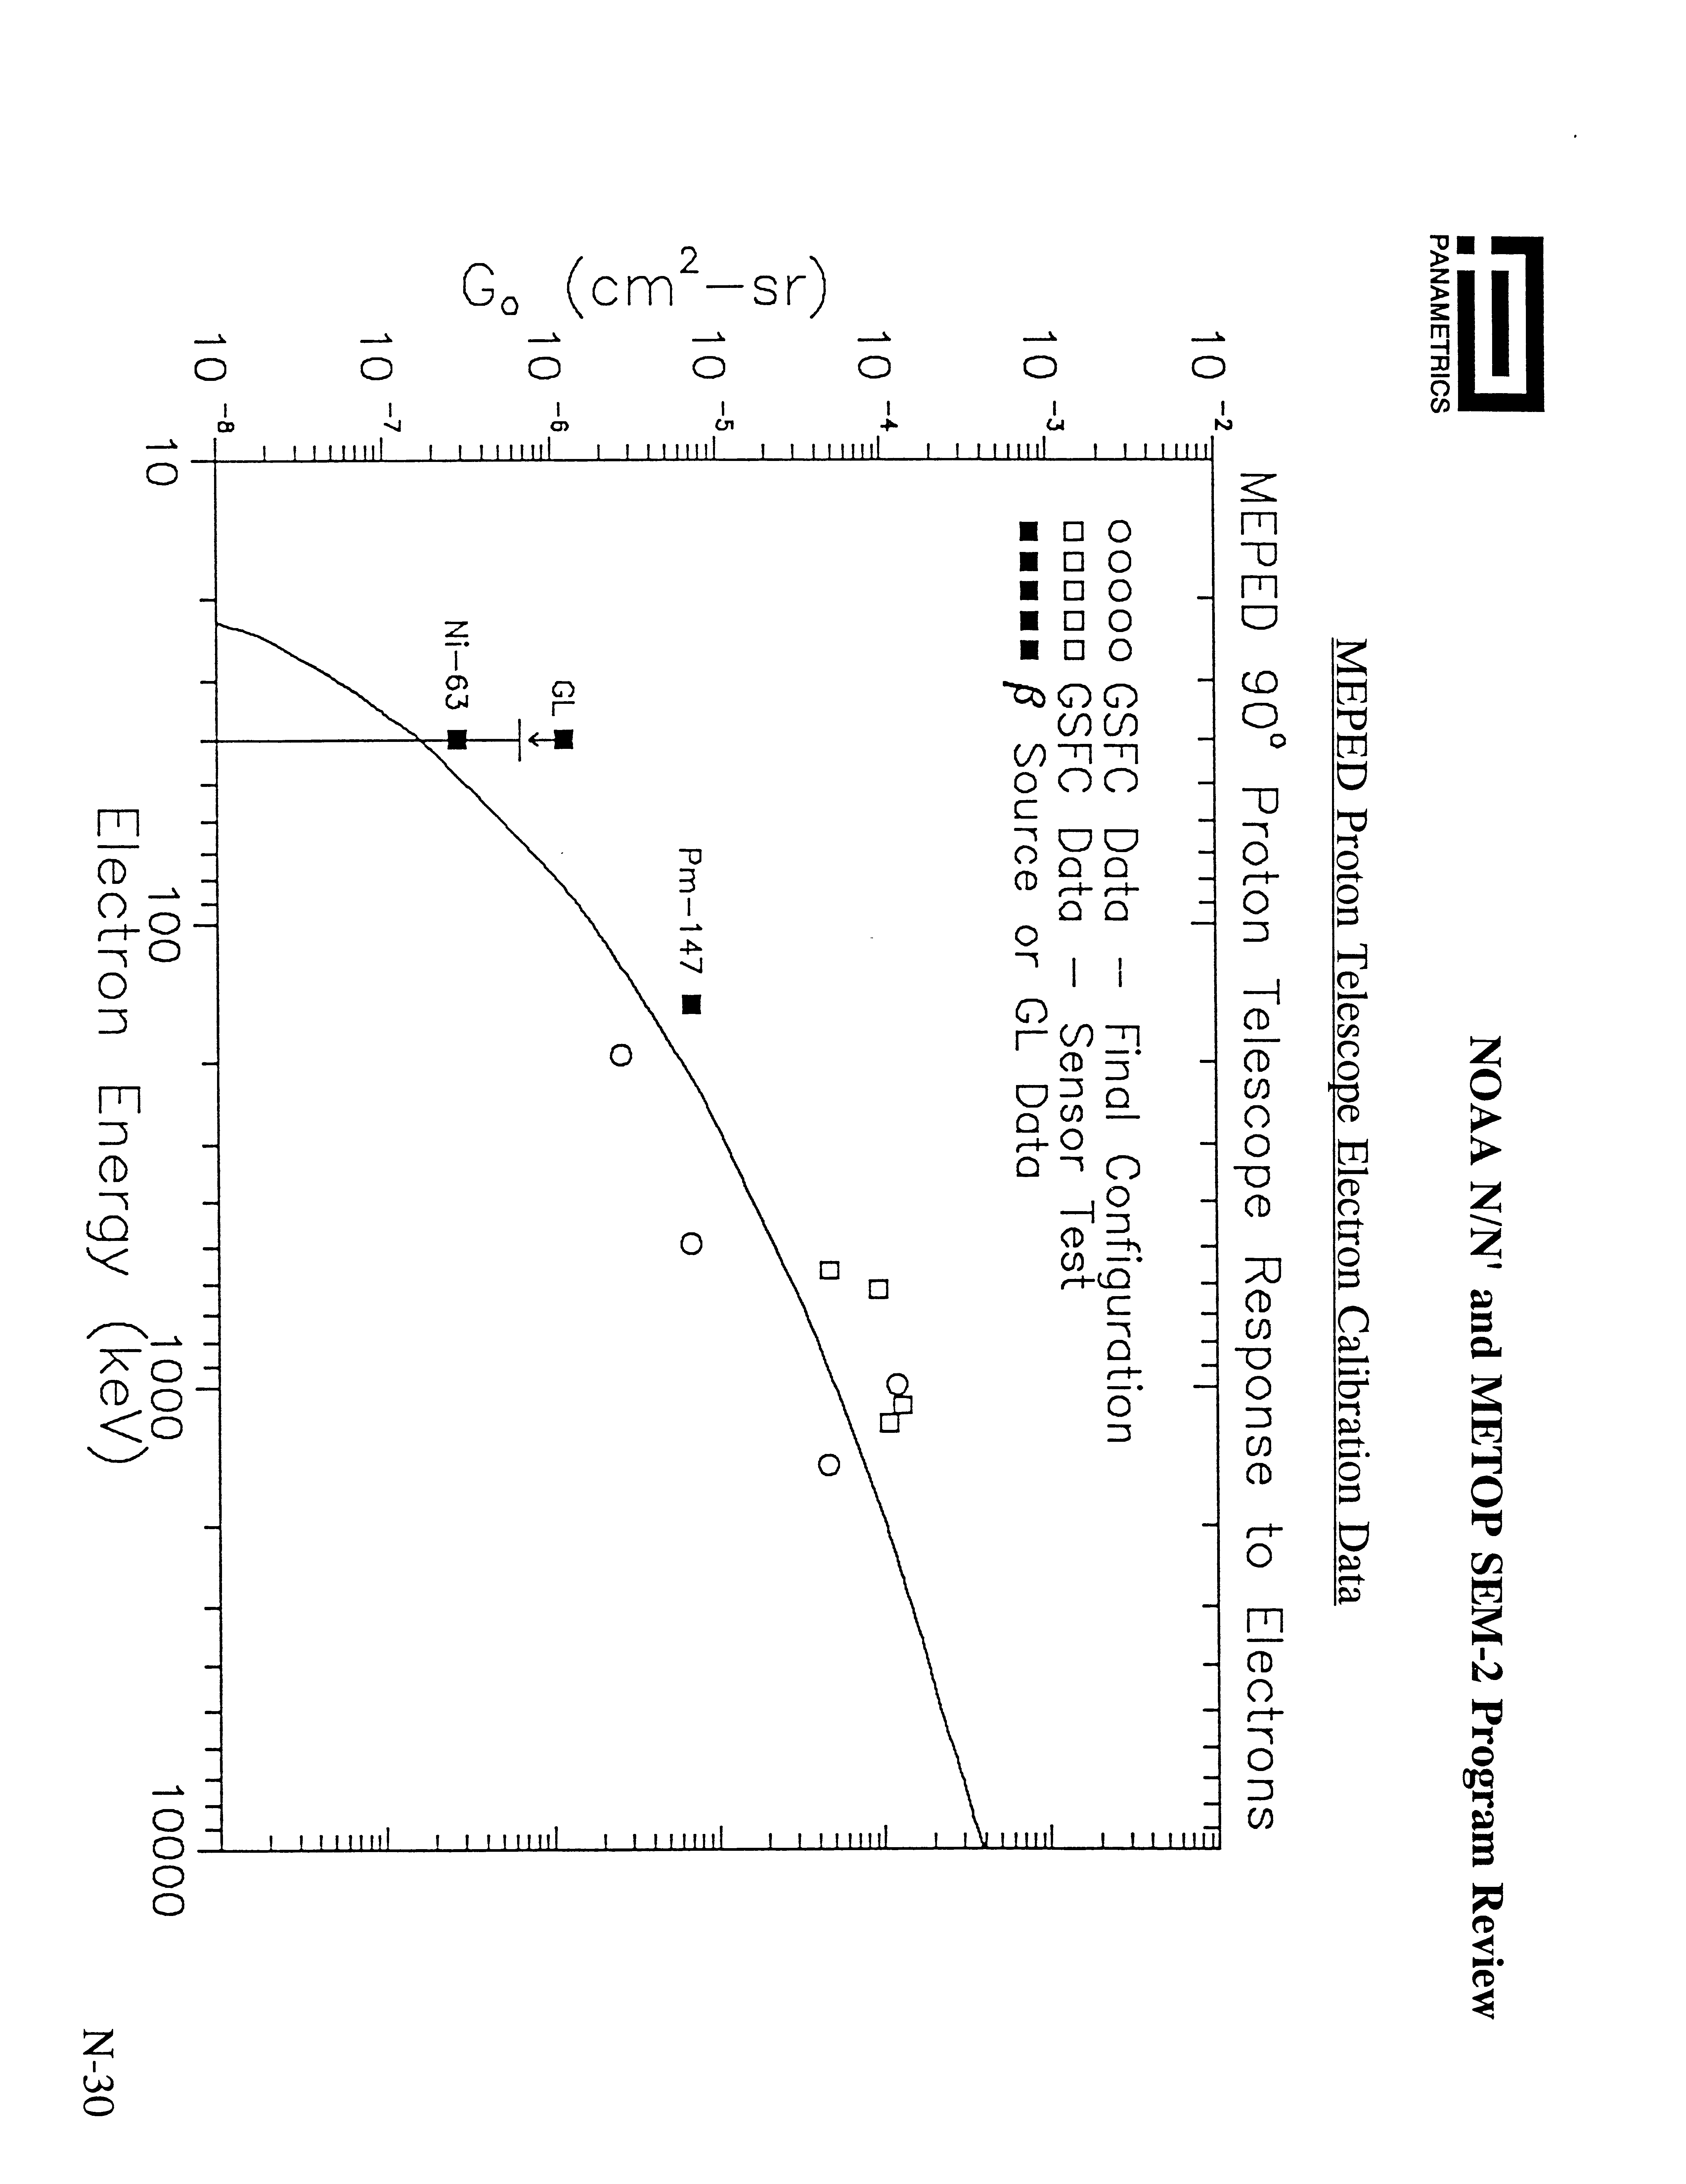

Figure C-1 Response of the proton telescope detector to electrons
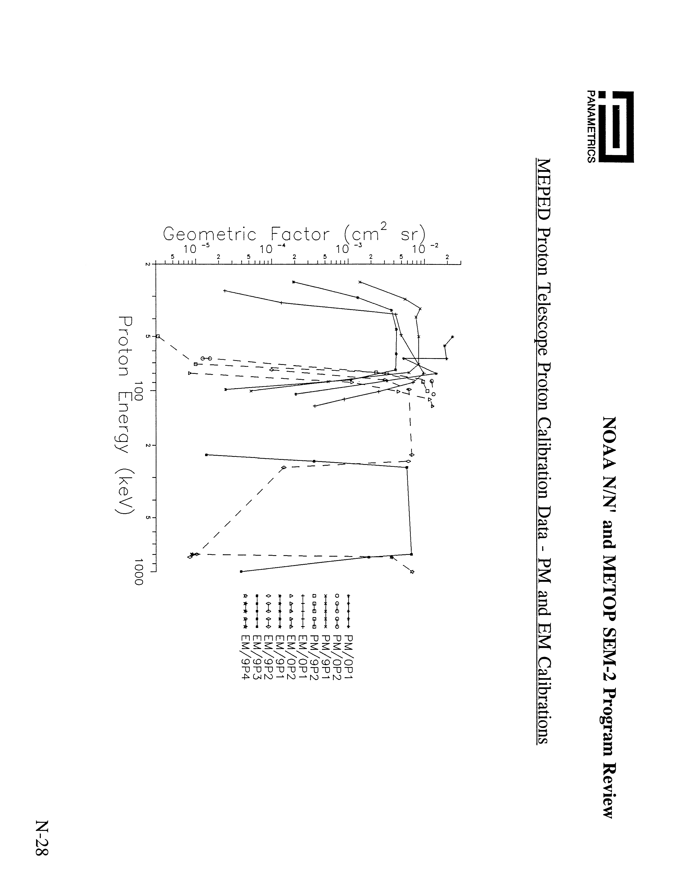
Figure C-2 Response of proton detectors to protons

Appendix D: Level 1B file format and Telemetry Description

Table D-1: The byte by byte description of the contents of the header record of a SEM incremental file.

Byte | Contents | Comments
001-003 | 3-character code for incremental file creation site | EBCDIC, normally NSS, ASCII
004 | ASCII blank character | ASCII 032 decimal
005-006 | Level 1b data format version number | currently 001
007-008 | Year of level 1b data format creation | currently 1998
009-010 | Day of level 1b data format creation | currently 051
011-012 | Number of bytes in logical record | currently 512
013-014 | Record block size | currently 512
015-016 | Number of header records in this incremental file | normally 001
017-018 | not used
019-060 | 42-character name of this incremental data file | EBCDIC, ASCII as of 2005
061-068 | 8-character processing block ID | EBCDIC, ASCII as of 2005
069-070 | Spacecraft ID | note (1)
071-072 | Instrument ID | normally 000
073-074 | Data type code | is 009 for SEM
075-076 | TIP source code | normally 000
077-080 | Day number from 1 Jan. 1950 at start of this data set | 19546 for July 8, 2003
081-082 | Year at start of this data set | 4-digit year
083-084 | Day of year at start of this data set | 3-digit day of year
085-088 | UT time in milliseconds at start of this data set | all 4 bytes used
089-092 | Day number from 1 Jan. 1950 at end of this data set | 19546 for July 8, 2003
093-094 | Year at end of this data set | 4-digit year
095-096 | Day of year at end of this data set | 3-digit day of year
097-100 | UT time in milliseconds at end of this data set | all 4 bytes used
101-102 | Year of last CPIDS update | note (2)
103-104 | Day of year of last CPIDS update | note (2)
105-112 | Not used
113-116 | TIP word 08, status 1 and 2 at start of this data set | note (3)
117-118 | Not used
119-120 | Data record number of any status change in TIP 08 | note (4)
121-124 | TIP word 08, status 1 and 2 after a status change | note (4)
125-126 | Number of 2-second data records in this data set | note (5)
127-128 | Number of data gaps in this data set
129-130 | Number of TIP minor frames without sync errors | note (5)
131-132 | Number of TIP parity errors detected by PACS
133-134 | Sum of all sync errors detected in this data set
Byte | Contents | Comments
135-136 | Time sequence error flag | note (6)
137-138 | Time sequence error code | note (7)
139-140 | SOCC clock update indicator | note (8)
141-142 | Earth location error indicator | note (9)
143-144 | Earth location error code | note (10)
145-146 | PACS status bit field | note (11)
147-148 | PACS data source | 1 is Fairbanks, 2 is Wallops
149-176 | Not used
177-184 | 8-character code for reference ellipsoid model ID | EBCDIC
185-186 | Nadir earth location tolerance | units are tenths of km

187-188 | Earth location bit field | note (12)
189-190 | Not used
191-192 | Spacecraft roll attitude error | units are .001 degrees
193-194 | Spacecraft pitch attitude error | units are .001 degrees
195-196 | Space craft yaw attitude error | units are .001 degrees
197-198 | Epoch year for satellite orbit vector | 4-digit year
199-200 | Epoch day of year for satellite orbit vector | 3-digit day, near byte 083-084
201-204 | Epoch UT time in milliseconds for orbit vector | all 4 bytes used
205-208 | Semi-major axis of orbit | note (13)
209-212 | Orbit eccentricity | note (14)
213-216 | Orbit inclination | note (15)
217-220 | Argument of perigee | note (16)
221-224 | Right ascension of the ascending node | note (16)
225-228 | Mean anomaly | note (16)
229-232 | Satellite location, x coordinate | note (17)
233-236 | Satellite location, y coordinate | note (17)
237-240 | Satellite location, z coordinate | note (17)
241-244 | Satellite velocity vector, x component | note (18)
245-248 | Satellite velocity vector, y component | note (18)
249-252 | Satellite velocity vector, z component | note (18)
253-256 | Earth/sun distance ratio | note (19)
257-512 | Not used

Notes for TableD-1

The bit numbering convention used below is the least significant bit within a byte is bit 01 and the most significant bit is bit 08. In the case of multiple bytes, the bit count increments from bit 01 of the highest numbered byte to bit 08 of the lowest numbered byte.

- Satellite ID is 2 for NOAA-15, 4 for NOAA-16 and 6 for NOAA-17
- CPIDS refers to a comprehensive calibration data set and these bytes provides the year
and day-of-year of the latest data set update.
- These bytes contain the contents of status1 and status2 from TIP word 08 at the
beginning time of this data set. The bit assignments are
bytes 113 and 114 not used
bit 8, MSB of byte 115 microprocessor system identifier
bit 7 TED IFC flag
bit 6 MEPED IFC Flag
bit 5 MSB of the TED electron pulse discriminator level
setting
bit 4 LSB of the TED electron pulse discriminator level
setting
bit 3 not used
bit 2 not used
bit 1, LSB of byte 115 not used
bit 8, MSB of byte 116 microprocessor A watchdog error
bit 7 microprocessor B watchdog error
bit 6 MSB of the TED proton pulse discriminator level
setting
bit 5 LSB of the TED proton pulse discriminator level
setting
bits 4-1 not used
See also the Notes for Table VI B-2
- If the contents of status1 or status2 change during the course of this data set, bytes 119-
120 contain the data record number of that change. Bytes 121-124 contain the contents
of status1 and status2 after that change with the bit assignments in note (3). Normally a
change in the contents of status1 or status2 is associated with an in-flight calibration.
- Bytes 125-126 contain the number of 2-second SEM data records in this incremental file.
Bytes 129-130 contain the number of TIP minor frames within this incremental file that
did not have sync errors. If there were no sync errors records, the integer number in
bytes 129-130 should be exactly 20 times the integer number in bytes 125-126 because
there are 20 TIP minor frames in each 2-second data record. If sync errors are present,
the value of bytes 129-130 will be less than 20 times the integer value of bytes 125-126.
(6) 0 = no time error; otherwise the record number of the first occurrence of an error
(7) If there is a time error, the following provides details of that error.
if a bit is set to 1, then the statement is true.
byte 137 not used
bit 8, MSB of byte 138 time field is bad but can probably be inferred from the
previous good time.
bit 7 time field is bad and can’t be inferred from the previous good
time.
bit 6 this record starts a sequence that is inconsistent with previous
times (i.e., there is a time discontinuity). This may or may not be associated with a spacecraft clock update.
bit 5 start of a sequence that apparently repeats scan times that
have been previously accepted.
bit 4 to 1 not used
(8) =0 if no clock update during this orbit; otherwise the record number of the first
occurrence of a clock update. Typically there is a spacecraft clock update of a few milliseconds each day.
(9) =0 if no error during this orbit; otherwise the record number of the first error in
earth location.
(10) If there is an earth location error, the following provides details of that error.
if a bit is set to 1, then the statement is true.
byte 143 not used
bit 8, MSB of byte 144 not earth located because of bad time; earth location fields zero filled.
bit 7 earth location questionable because of questionable time code (See time problem flags.)
bit 6 earth location questionable—only marginal agreement with reasonableness check.
bit 5 earth location questionable—fails reasonableness check
bit s 4 to 1 not used
(11) These bytes not used in SEM data processing. For the record,
byte 145, not used
bit 8 MSB of byte 146 not used
bits 7-4 not used
bit 3 0 if data stream is normal, 1 if data is pseudo noise
bit 2 0 if tape playback was in reverse, 1 if forward
bit 1, LSB of byte 146 0 if data stream is test, 1 if data stream is flight data
Normally, the value of byte 146 is decimal 3, bits 1 and 2 set to 1
(12) This is not used in SEM processing
(13) The integer number in bytes 205-208 is divided by decimal 100000. to obtain the semi-
major axis in kilometers.
(14) The integer number in bytes 209-212 is divided by 100000000. to obtain the orbit
eccentricity. Note that a survey of header files shows the eccentricity (and the semi-major axis) varies a great deal day to day. The orbit eccentricity given in the 2-line NORAD orbit elements obtained from http://celestrak.com/NORAD/elements/noaa.txt
do not show nearly that variation and the NORAD eccentricities generally do not agree with those obtained from this header record. There is no explanation for this.
(15) The orbit inclination in degrees is obtained from the integer number in bytes 213-216 by
dividing by decimal 100000. The orbital inclination is used in SEM data processing.
(16) The integer values of these parameters are divided by decimal 100000. to obtain the
physical parameters in degrees.
(17) The integer values of these 4-byte signed integers are divided by decimal 100000. to
obtain the satellite location in kilometers at the epoch time given in bytes 197-204 in earth-centered inertial coordinates. That is, the Z axis directed north parallel to earth’s axis of rotation, X axis directed toward the vernal equinox, and the Y axis completing the right handed Cartesian coordinate system.
(18) The integer values of these 4-byte signed integers are divided by decimal 100000000. to
obtain the satellite velocity vector in kilometers per second at the epoch time given in bytes 197-204. The coordinate system is earth-centered inertial.
(19) The earth/sun distance ratio is obtained by dividing the integer value of bytes 253-256 by
decimal 1000000. The definition of the earth/sun distance ratio is not known although the numerical value of this ratio is close to 1.0
TableD-2

A sequence of data records follow the header record in an incremental file. Usually an incremental file contains about one orbit’s data or about 6000 seconds. A single physical 512 byte data record in the file contains 2-seconds of data so that each incremental file contains about 3000 physical data records. Each 2-second data record contains 20 TIP minor frames of data, parsed so that the first minor frame is always mod 020. That is, the first TIP minor frame in each data record is either 000, 020, 040, 060, 080, 100, 120, 140, 160, 180, 200, 220, 240, 260, 280, or 300. The following is a byte by byte description of the contents of an incremental file data record.
Table D-2: Description of Data Record
Byte | Contents | Comments
001-002 | TIP major frame number 0 to 7
003-004 | TIP minor frame number at start of this 2-second data record
005-006 | 4-digit year at start of this 2-second data record
007-008 | 3 digit day of year at start of this 2-second data record
009-010 | Not used
011-012 | Satellite clock drift relative to UTC in milliseconds | nominally near zero
013-016 | Time in milliseconds the day at start of this 2-second record
017-018 | Satellite travel direction indicator, north or south | note (1)
019-028 | Not used
029-032 | Quality indicator flags | note (2)
033-036 | Time quality and satellite location quality flags | note (3)
037-048 | Not used
049-052 | Satellite orbital navigation/attitude status flags | note (4)
053-056 | Time associated with TIP Euler angles | note (5)
057-058 | Roll Euler angle | note (5)
059-060 | Pitch Euler angle | note (5)
061-062 | Yaw Euler angle | note (5)
063-064 | Satellite altitude above reference geoid in tenths km
065-068 | Geodetic sub-satellite latitude | note (6)
069-072 | Geodetic sub-satellite longitude | note (6)
073-080 | Not used
081-088 | Missing data flags, 20 entries each for TIP word 20 and 21 | note (7)
089 | TIP word 20, start TIP minor frame plus 00
090 | TIP word 21, start TIP minor frame plus 00
091 | TIP word 20, start TIP minor frame plus 01
092 | TIP word 21, start TIP minor frame plus 01
093 | TIP word 20, start TIP minor frame plus 02
094 | TIP word 21, start TIP minor frame plus 02
095 | TIP word 20, start TIP minor frame plus 03
096 | TIP word 21, start TIP minor frame plus 03
097 | TIP word 20, start TIP minor frame plus 04
098 | TIP word 21, start TIP minor frame plus 04
099 | TIP word 20, start TIP minor frame plus 05
100 | TIP word 21, start TIP minor frame plus 05
101 | TIP word 20, start TIP minor frame plus 06
102 | TIP word 21, start TIP minor frame plus 06
103 | TIP word 20, start TIP minor frame plus 07

Byte | Contents | Comments
104 | TIP word 21, start TIP minor frame plus 07
105 | TIP word 20, start TIP minor frame plus 08
106 | TIP word 21, start TIP minor frame plus 08
107 | TIP word 20, start TIP minor frame plus 09
108 | TIP word 21, start TIP minor frame plus 09
109 | TIP word 20, start TIP minor frame plus 10
110 | TIP word 21, start TIP minor frame plus 10
111 | TIP word 20, start TIP minor frame plus 11
112 | TIP word 21, start TIP minor frame plus 11
113 | TIP word 20, start TIP minor frame plus 12
114 | TIP word 21, start TIP minor frame plus 12
115 | TIP word 20, start TIP minor frame plus 13
116 | TIP word 21, start TIP minor frame plus 13
117 | TIP word 20, start TIP minor frame plus 14
118 | TIP word 21, start TIP minor frame plus 14
119 | TIP word 20, start TIP minor frame plus 15
120 | TIP word 21, start TIP minor frame plus 15
121 | TIP word 20, start TIP minor frame plus 16
122 | TIP word 21, start TIP minor frame plus 16
123 | TIP word 20, start TIP minor frame plus 17
124 | TIP word 21, start TIP minor frame plus 17
125 | TIP word 20, start TIP minor frame plus 18
126 | TIP word 21, start TIP minor frame plus 18
127 | TIP word 20, start TIP minor frame plus 19
128 | TIP word 21, start TIP minor frame plus 19
129-132 | Not used
133-134 | TIP word 08 status1 and status2 availability flags | note (8)
135-136 | TIP word 08 status1 and status2 contents | note (9)
137-140 | Not used
141-144 | TIP word 09 and word 10 housekeeping availability flags | note (10)
145-166 | TIP word 09 and word 10 housekeeping values | note (11)
167-512 | Not used
Notes for Table 17

This documentation is obtained from Table 8.3.1.8.3-1 of the NOAA KLM Users Guide available from URL http://www2.ncdc.noaa.gov/docs/klm/index.htm. As noted below, it appears some of this documentation is in error.

- The direction of satellite travel is required for calculation of sensor look angles with
respect to the geomagnetic field
- These bytes key various timing and earth location problems according to the following
bit assignments. If the bit is set to 1, the statement is true.
bit 8, MSB of byte 29 this 2-second frame is not valid
bit 7 time sequence error in this 2-second frame
bit 6 a data gap precedes this 2-second frame
bit 5 not used
bit 4 earth location data not available (bytes 65-72 set to zero)
bit 3 first good time following a s/c clock update
bit 2 SEM instrument status changed beginning this frame
bit 1, LSB of byte 29 not used
bytes 30-32 not used
- These bytes provide details of the problems flagged in bytes 29-32. If the bit is set to 1 the statement is true.
byte 33 not used
bit 8, MSB of byte 34 time is bad but probably can be inferred from previous time
bit 7 time is bad and cannot be inferred from previous time
bit 6 there is a time discontinuity, including a clock update
bit 5 this time starts a sequence that duplicates previous times
bits 4-1 not used
byte 35 not used
bit 8, MSB of byte 36 no earth location because of bad time. (bytes 65-72 set to zero)
bit 7 earth location questionable because of questionable time
bit 6 earth location questionable – marginal agreement with ‘reasonableness check’
bit 5 earth location questionable – fails ‘reasonableness check’
bits 04-01 not used.
(4) These bytes key satellite location and attitude problems. Detailed documentation of the
contents of these bytes is given in the NOAA KLM Users Guide. However, a survey of
the data in the incremental files shows that bytes 49-52 are always zero and it seems that
satellite attitude quality flags are not introduced in the SEM-2 incremental data file
(5) These bytes contain information about the actual satellite attitude. Detailed
documentation of the contents of these bytes is given in the NOAA KLM Users Guide. However, a survey of data in the incremental files shows that bytes 53-62 are always zero and it seems that satellite attitude status data are not introduced in the SEM-2 incremental data file
- The signed integer values bytes 65-68 and 69-72 are divided by decimal 10000. to obtain the sub-satellite latitude and longitude respectively. Latitudes are negative in the southern hemisphere and the longitude is negative in the western hemisphere.
- The incremental data file flags those instances when data from TIP words 20 and 21 could not be recovered because of bit sync loss and the data padded with value 000. This information is important to the further processing of SEM-2 data. The bit assignments in bytes 81-88 are as follows
bits 8-1, byte 81 not used
bits 8-1, byte 82 not used
bits 8-2, byte 83 not used
bit 1 LSB of byte 83 if 1, TIP word 21, minor frame +19 is padded
bit 8, MSB of byte 84 if 1, TIP word 20, minor frame +19 is padded
bit 7 if 1, TIP word 21, minor frame +18 is padded
bit 6 if 1, TIP word 20, minor frame +18 is padded
bit 5 if 1, TIP word 21, minor frame +17 is padded
bit 4 if 1, TIP word 20, minor frame +17 is padded
bit 3 if 1, TIP word 21, minor frame +16 is padded
bit 2 if 1, TIP word 20, minor frame +16 is padded
bit 1, LSB of byte 84 if 1, TIP word 21, minor frame +15 is padded
bit 8, MSB of byte 85 if 1, TIP word 20, minor frame +15 is padded
bit 7 if 1, TIP word 21, minor frame +14 is padded
bit 6 if 1, TIP word 20, minor frame +14 is padded
bit 5 if 1, TIP word 21, minor frame +13 is padded
bit 4 if 1, TIP word 20, minor frame +13 is padded
bit 3 if 1, TIP word 21, minor frame +12 is padded
bit 2 if 1, TIP word 20, minor frame +12 is padded
bit 1, LSB of byte 85 if 1, TIP word 21, minor frame +11 is padded
bit 8, MSB of byte 86 if 1, TIP word 20, minor frame +11 is padded
bit 7 if 1, TIP word 21, minor frame +10 is padded
bit 6 if 1, TIP word 20, minor frame +10 is padded
bit 5 if 1, TIP word 21, minor frame +09 is padded
bit 4 if 1, TIP word 20, minor frame +09 is padded
bit 3 if 1, TIP word 21, minor frame +08 is padded
bit 2 if 1, TIP word 20, minor frame +08 is padded
bit 1, LSB of byte 86 if 1, TIP word 21, minor frame +07 is padded
bit 8, MSB of byte 87 if 1, TIP word 20, minor frame +07 is padded
bit 7 if 1, TIP word 21, minor frame +06 is padded
bit 6 if 1, TIP word 20, minor frame +06 is padded
bit 5 if 1, TIP word 21, minor frame +05 is padded
bit 4 if 1, TIP word 20, minor frame +05 is padded
bit 3 if 1, TIP word 21, minor frame +04 is padded
bit 2 if 1, TIP word 20, minor frame +04 is padded
bit 1, LSB of byte 87 if 1, TIP word 21, minor frame +03 is padded
bit 8, MSB of byte 88 if 1, TIP word 20, minor frame +03 is padded
bit 7 if 1, TIP word 21, minor frame +02 is padded
bit 6 if 1, TIP word 20, minor frame +02 is padded
bit 5 if 1, TIP word 21, minor frame +01 is padded
bit 4 if 1, TIP word 20, minor frame +01 is padded
bit 3 if 1, TIP word 21, minor frame +00 is padded
bit 2 if 1, TIP word 20, minor frame +00 is padded
bit 1, LSB of byte 88 not used

- Bytes 133 to 134 key whether updated instrument status data from TIP word 08 is in this minor frame. The bit assignments are as follows
bit 8, MSB of byte 133 if 0, update of microprocessor system ID occurred
bit 7 if 0, update of TED IFC status occurred
bit 6 if 0, update of MEPED IFC status occurred
bit 5 if 0, update of TED electron PHD level occurred, MSB
bit 4 if 0, update of TED electron PHD level occurred, LSB
bits 3-1 not used
bit 8, MSB of byte 134 if 0, update of microprocessor A watchdog occurred
bit 7 if 0, update of microprocessor B watchdog occurred
bit 6 if 0, update of TED proton PHD level occurred, MSB
bit 5 if 0, update of TED proton PHD level occurred, LSB
bits 4-1 not used
(9) Bytes 135-136 contain the actual instrument status bits according to the following assignments
bit 8, MSB of byte 135 microprocessor system ID, 0 for processor A
bit 7 TED IFC, 0=off, 1=on
bit 6 MEPED IFC, 0=off, 1=on
bit 5 TED electron PHD level, MSB
bit 4 TED electron PHD level, LSB
bits 3-1 not used
bit 8, MSB of byte 136 microprocessor A watchdog, 0=normal
bit 7 microprocessor B watchdog, 0=normal
bit 6 TED proton PHD level, MSB
bit 5 TED proton PHD level, LSB
bits 4-1 not used
(10) Bytes 141-144 key whether updated instrument analog housekeeping data from TIP words 09 and 10 are in this minor frame. The bit assignments are as follows
byte 141 not used
bit 8, MSB of byte 142 not used
bit 7 if 0, update of primary bus voltage monitor
bit 6 if 0, update of backup pitch coil driver monitor (attitude control)
bit 5 if 0, update of primary pitch coil driver monitor (attitude control)
bit 4 if 0, update of backup roll/yaw coil driver
bit 3 if 0, update of primary roll/yaw coil driver
bit 2 if 0, update of Z axis gyro torque current monitor
bit 1, LSB of byte 142 if 0, update of Y axis gyro torque current monitor
bit 8, MSB of byte 143 if 0, update of X axis gyro torque current monitor
bit 7 if 0, update of S gyro torque current monitor
bit 6 if 0, update of DPU temperature monitor
bit 5 if 0, update of TED temperature monitor
bit 4 if 0, update MEPED proton telescope temperature monitor
bit 3 if 0, update of MEPED circuit temperature monitor
bit 2 if 0, update of Omni detector bias voltage monitor
bit=1, LSB of byte 143 if 0, update of TED proton CEM high voltage monitor

bit 8, MSB of byte 144 if 0, update of TED electron CEM high voltage monitor
bit 7 if 0, update of TED sweep voltage monitor
bit 6 if 0, update of TED +5V monitor
bit 5 if 0, update of MEPED +5V monitor
bit 4 if 0, update of DPU +5V monitor
bit 3 if 0, update of microprocessor B +5V monitor
bit 2 if 0, update of microprocessor A +5V monitor
bit 1, LSB of byte 144 not used
(11) Actual values of TIP analog housekeeping words 09 and 10 refreshed only when the corresponding bit in bytes 142-144 is set to 0.
byte 145 microprocessor A +5V monitor
byte 146 microprocessor B +5V monitor
byte 147 DPU +5V monitor
byte 148 MEPED +5V monitor
byte 149 TED +5V monitor
byte 150 TED sweep voltage monitor
byte 151 TED electron CEM high voltage monitor
byte 152 TED proton CEM high voltage monitor
byte 153 MEPED Omni detector bias voltage monitor
byte 154 MEPED electronics circuit temperature monitor
byte 155 MEPED proton telescope temperature monitor
byte 156 TED temperature monitor
byte 157 DPU temperature monitor
byte 158 S gyro torque current monitor
byte 159 X gyro torque current monitor
byte 160 Y gyro torque current monitor
byte 161 Z gyro torque current monitor
byte 162 Primary roll/yaw coil driver current monitor
byte 163 Backup roll/yaw coil driver current monitor
byte 164 Primary pitch coil driver current monitor
byte 165 Backup pitch coil driver current monitor
byte 166 Primary bus voltage monitor

An extensive survey of SEM incremental data files was done to verify this documentation. Of the bytes between 29 and 62 inclusive, that include navigation error flags and information about the Euler angles, only bytes 29, 34, and 36 ever show values other than 000. The conclusion is that, the documentation notwithstanding, navigation/attitude status flags (bytes 49-52) and Euler angle information (bytes 53-62) are not provided.

Moreover, certain bits in bytes 29, 34, and 36, that are defined as providing status, never seem to be used. Specifically: bit 3 in byte 29 (first good time following a s/c clock update) is never set to 1; bit 8 in byte 34 (time is bad but probably can be inferred from previous time) nor bit 5 in byte 34 (this time starts a sequence that duplicates previous times) are never set to 1; bit 6 in byte 36 (earth location questionable – marginal agreement with ‘reasonableness check’) nor bit 5 in byte 36 (earth location questionable – fails ‘reasonableness check’) are never set to 1.

The study did confirm that bit 2 in byte 29 (SEM instrument status changed beginning this frame) is a reliable indicator of when the TED or MEPED are undergoing IFC. The combination of bit 8 in byte 29 (this 2-second frame is not valid) set to 1, bit 7 in byte 29 (time sequence error in this 2-second frame) set to 1, bit 4 in byte 29 (earth location data not available) set to 1, AND bit 8 in byte 36 (no earth location because of bad time) set to 1 proves to be a reliable indicator of zero fill in the earth location field (bytes 65 to 72.)

Information about when the magnetic torque coils were energized, a procedure required to maintain S/C attitude control, was introduced into the SEM data record. This was done because of concern that when the coils were energized the measurement of low energy particles by the TED would be compromised. The analysis to determine whether or not the TED observations are influenced by the torque coils has not been done. However, it was verified that data in bytes 162 to 165 do reflect those times when the roll/yaw and pitch coils are energized and so that analysis of any impact on TED can be done.
Table D-3: SEM-2 data allocations in TIP words 20 and 21 for a single TIP 32 second major frame. Refer to notes for those entries in bold (data channels whose content depends upon the DPU major frame count) or italic.

TIP minor | TIP word 20 | TIP word 21 |  | TIP minor | TIP word 20 | TIP word 21
frame count | contents | contents |  | frame count | contents | contents
000 | CHECK SUM | 0 P1 |  | 040 | TED E CEM HV | 0 P1
001 | 0 P2 | 0 P3 |  | 041 | 0 P2 | 0 P3
002 | 0 P4 | 0 P5 |  | 042 | 0 P4 | 0 P5
003 | 0 P6 | 0 E1 |  | 043 | 0 P6 | 0 E1
004 | 0 E2 | 0 E3 |  | 044 | 0 E2 | 0 E3
005 | 90 P1 | 90 P2 |  | 045 | 90 P1 | 90 P2
006 | 90 P3 | 90 P4 |  | 046 | 90 P3 | 90 P4
007 | 90 P5 | 90 P6 |  | 047 | 90 P5 | 90 P6
008 | 90 E1 | 90 E2 |  | 048 | 90 E1 | 90 E2
009 | 90 E3 | P6 |  | 049 | 90 E3 | P6
010 | P7 | P8 |  | 050 | P7 | P8
011 | 0 DE1 | 0 DE2 |  | 051 | 0 DP1 | 0 DP2
012 | 0 DE3 | 0 DE4 |  | 052 | 0 DP3 | 0 DP4
013 | 0 EF-L | 30 EF-L |  | 053 | 0 EF-L | 30 EF-L
014 | 0 PF-L | 30 PF-L |  | 054 | 0 PF-L | 30 PF-L
015 | 0 EF-H | 30 EF-H |  | 055 | 0 EF-H | 30 EF-H
016 | 0 PF-H | 30 PF-H |  | 056 | 0 PF-H | 30 PF-H
017 | 0 EM/ 0 PM | 0 DEM |  | 057 | 0 EM/ 0 PM | 0 DEM
018 | 0 DPM | 30 EM/ 30 PM |  | 058 | 0 DPM | 30 EM/ 30 PM
019 | 30 DEM | 30 DPM |  | 059 | 30 DEM | 30 DPM
020 | TED Swp V Mon | 0 P1 |  | 060 | TED P CEM HV | 0 P1
021 | 0 P2 | 0 P3 |  | 061 | 0 P2 | 0 P3
022 | 0 P4 | 0 P5 |  | 062 | 0 P4 | 0 P5
023 | 0 P6 | 0 E1 |  | 063 | 0 P6 | 0 E1
024 | 0 E2 | 0 E3 |  | 064 | 0 E2 | 0 E3
025 | 90 P1 | 90 P2 |  | 065 | 90 P1 | 90 P2
026 | 90 P3 | 90 P4 |  | 066 | 90 P3 | 90 P4
027 | 90 P5 | 90 P6 |  | 067 | 90 P5 | 90 P6
028 | 90 E1 | 90 E2 |  | 068 | 90 E1 | 90 E2
029 | 90 E3 | P6 |  | 069 | 90 E3 | P6
030 | P7 | P9 |  | 070 | P7 | P9
031 | 30 DE1 | 30 DE2 |  | 071 | 30 DP1 | 30 DP2
032 | 30 DE3 | 30 DE4 |  | 072 | 30 DP3 | 30 DP4
033 | 0 EF-L | 30 EF-L |  | 073 | 0 EF-L | 30 EF-L
034 | 0 PF-L | 30 PF-L |  | 074 | 0 PF-L | 30 PF-L
035 | 0 EF-H | 30 EF-H |  | 075 | 0 EF-H | 30 EF-H
036 | 0 PF-H | 30 PF-H |  | 076 | 0 PF-H | 30 PF-H
037 | 0 EM/ 0 PM | 0 DEM |  | 077 | 0 EM/ 0 PM | 0 DEM
038 | 0 DPM | 30 EM/ 30 PM |  | 078 | 0 DPM | 30 EM/ 30 PM
039 | 30 DEM | 30 DPM |  | 079 | 30 DEM | 30 DPM

TIP minor | TIP word 20 | TIP word 21 |  | TIP minor | TIP word 20 | TIP word 21
frame count | contents | contents |  | frame count | contents | contents
080 | MEP OMNI BV | 0 P1 |  | 120 | Analog S/C 2 | 0 P1
081 | 0 P2 | 0 P3 |  | 121 | 0 P2 | 0 P3
082 | 0 P4 | 0 P5 |  | 122 | 0 P4 | 0 P5
083 | 0 P6 | 0 E1 |  | 123 | 0 P6 | 0 E1
084 | 0 E2 | 0 E3 |  | 124 | 0 E2 | 0 E3
085 | 90 P1 | 90 P2 |  | 125 | 90 P1 | 90 P2
086 | 90 P3 | 90 P4 |  | 126 | 90 P3 | 90 P4
087 | 90 P5 | 90 P6 |  | 127 | 90 P5 | 90 P6
088 | 90 E1 | 90 E2 |  | 128 | 90 E1 | 90 E2
089 | 90 E3 | P6 |  | 129 | 90 E3 | P6
090 | P7 | P8 |  | 130 | P7 | P8
091 | 0 DE1 | 0 DE2 |  | 131 | 0 DP1 | 0 DP2
092 | 0 DE3 | 0 DE4 |  | 132 | 0 DP3 | 0 DP4
093 | 0 EF-L | 30 EF-L |  | 133 | 0 EF-L | 30 EF-L
094 | 0 PF-L | 30 PF-L |  | 134 | 0 PF-L | 30 PF-L
095 | 0 EF-H | 30 EF-H |  | 135 | 0 EF-H | 30 EF-H
096 | 0 PF-H | 30 PF-H |  | 136 | 0 PF-H | 30 PF-H
097 | 0 EM/ 0 PM | 0 DEM |  | 137 | 0 EM/ 0 PM | 0 DEM
098 | 0 DPM | 30 EM/ 30 PM |  | 138 | 0 DPM | 30 EM/ 30 PM
099 | 30 DEM | 30 DPM |  | 139 | 30 DEM | 30 DPM
100 | Analog S/C 1 | 0 P1 |  | 140 | Analog S/C 3 | 0 P1
101 | 0 P2 | 0 P3 |  | 141 | 0 P2 | 0 P3
102 | 0 P4 | 0 P5 |  | 142 | 0 P4 | 0 P5
103 | 0 P6 | 0 E1 |  | 143 | 0 P6 | 0 E1
104 | 0 E2 | 0 E3 |  | 144 | 0 E2 | 0 E3
105 | 90 P1 | 90 P2 |  | 145 | 90 P1 | 90 P2
106 | 90 P3 | 90 P4 |  | 146 | 90 P3 | 90 P4
107 | 90 P5 | 90 P6 |  | 147 | 90 P5 | 90 P6
108 | 90 E1 | 90 E2 |  | 148 | 90 E1 | 90 E2
109 | 90 E3 | P6 |  | 149 | 90 E3 | P6
110 | P7 | P9 |  | 150 | P7 | P9
111 | 30 DE1 | 30 DE2 |  | 151 | 30 DP1 | 30 DP2
112 | 30 DE3 | 30 DE4 |  | 152 | 30 DP3 | 30 DP4
113 | 0 EF-L | 30 EF-L |  | 153 | 0 EF-L | 30 EF-L
114 | 0 PF-L | 30 PF-L |  | 154 | 0 PF-L | 30 PF-L
115 | 0 EF-H | 30 EF-H |  | 155 | 0 EF-H | 30 EF-H
116 | 0 PF-H | 30 PF-H |  | 156 | 0 PF-H | 30 PF-H
117 | 0 EM/ 0 PM | 0 DEM |  | 157 | 0 EM/ 0 PM | 0 DEM
118 | 0 DPM | 30 EM/ 30 PM |  | 158 | 0 DPM | 30 EM/ 30 PM
119 | 30 DEM | 30 DPM |  | 159 | 30 DEM | 30 DPM

TIP minor | TIP word 20 | TIP word 21 |  | TIP minor | TIP word 20 | TIP word 21
frame count | contents | contents |  | frame count | contents | contents
160 | Analog S/C 4 | 0 P1 |  | 200 | MEP IFC V | 0 P1
161 | 0 P2 | 0 P3 |  | 201 | 0 P2 | 0 P3
162 | 0 P4 | 0 P5 |  | 202 | 0 P4 | 0 P5
163 | 0 P6 | 0 E1 |  | 203 | 0 P6 | 0 E1
164 | 0 E2 | 0 E3 |  | 204 | 0 E2 | 0 E3
165 | 90 P1 | 90 P2 |  | 205 | 90 P1 | 90 P2
166 | 90 P3 | 90 P4 |  | 206 | 90 P3 | 90 P4
167 | 90 P5 | 90 P6 |  | 207 | 90 P5 | 90 P6
168 | 90 E1 | 90 E2 |  | 208 | 90 E1 | 90 E2
169 | 90 E3 | P6 |  | 209 | 90 E3 | P6
170 | P7 | P8 |  | 210 | P7 | P8
171 | 0 DE1 | 0 DE2 |  | 211 | 0 DP1 | 0 DP2
172 | 0 DE3 | 0 DE4 |  | 212 | 0 DP3 | 0 DP4
173 | 0 EF-L | 30 EF-L |  | 213 | 0 EF-L | 30 EF-L
174 | 0 PF-L | 30 PF-L |  | 214 | 0 PF-L | 30 PF-L
175 | 0 EF-H | 30 EF-H |  | 215 | 0 EF-H | 30 EF-H
176 | 0 PF-H | 30 PF-H |  | 216 | 0 PF-H | 30 PF-H
177 | 0 EM/ 0 PM | 0 DEM |  | 217 | 0 EM/ 0 PM | 0 DEM
178 | 0 DPM | 30 EM/ 30 PM |  | 218 | 0 DPM | 30 EM/ 30 PM
179 | 30 DEM | 30 DPM |  | 219 | 30 DEM | 30 DPM
180 | TED IFC V | 0 P1 |  | 220 | Digital Status 1 | 0 P1
181 | 0 P2 | 0 P3 |  | 221 | 0 P2 | 0 P3
182 | 0 P4 | 0 P5 |  | 222 | 0 P4 | 0 P5
183 | 0 P6 | 0 E1 |  | 223 | 0 P6 | 0 E1
184 | 0 E2 | 0 E3 |  | 224 | 0 E2 | 0 E3
185 | 90 P1 | 90 P2 |  | 225 | 90 P1 | 90 P2
186 | 90 P3 | 90 P4 |  | 226 | 90 P3 | 90 P4
187 | 90 P5 | 90 P6 |  | 227 | 90 P5 | 90 P6
188 | 90 E1 | 90 E2 |  | 228 | 90 E1 | 90 E2
189 | 90 E3 | P6 |  | 229 | 90 E3 | P6
190 | P7 | P9 |  | 230 | P7 | P9
191 | 30 DE1 | 30 DE2 |  | 231 | 30 DP1 | 30 DP2
192 | 30 DE3 | 30 DE4 |  | 232 | 30 DP3 | 30 DP4
193 | 0 EF-L | 30 EF-L |  | 233 | 0 EF-L | 30 EF-L
194 | 0 PF-L | 30 PF-L |  | 234 | 0 PF-L | 30 PF-L
195 | 0 EF-H | 30 EF-H |  | 235 | 0 EF-H | 30 EF-H
196 | 0 PF-H | 30 PF-H |  | 236 | 0 PF-H | 30 PF-H
197 | 0 EM/ 0 PM | 0 DEM |  | 237 | 0 EM/ 0 PM | 0 DEM
198 | 0 DPM | 30 EM/ 30 PM |  | 238 | 0 DPM | 30 EM/ 30 PM
199 | 30 DEM | 30 DPM |  | 239 | 30 DEM | 30 DPM

TIP minor | TIP word 20 | TIP word 21 |  | TIP minor | TIP word 20 | TIP word 21
frame count | contents | contents |  | frame count | contents | contents
240 | Digital Status 2 | 0 P1 |  | 280 | 0 E-H BKG | 0 P1
241 | 0 P2 | 0 P3 |  | 281 | 0 P2 | 0 P3
242 | 0 P4 | 0 P5 |  | 282 | 0 P4 | 0 P5
243 | 0 P6 | 0 E1 |  | 283 | 0 P6 | 0 E1
244 | 0 E2 | 0 E3 |  | 284 | 0 E2 | 0 E3
245 | 90 P1 | 90 P2 |  | 285 | 90 P1 | 90 P2
246 | 90 P3 | 90 P4 |  | 286 | 90 P3 | 90 P4
247 | 90 P5 | 90 P6 |  | 287 | 90 P5 | 90 P6
248 | 90 E1 | 90 E2 |  | 288 | 90 E1 | 90 E2
249 | 90 E3 | P6 |  | 289 | 90 E3 | P6
250 | P7 | P8 |  | 290 | P7 | P8
251 | 0 DE1 | 0 DE2 |  | 291 | 0 E-L BKG | 30 E-L BKG
252 | 0 DE3 | 0 DE4 |  | 292 | 0 P-L BKG | 0 P-H BKG
253 | 0 EF-L | 30 EF-L |  | 293 | 0 EF-L | 30 EF-L
254 | 0 PF-L | 30 PF-L |  | 294 | 0 PF-L | 30 PF-L
255 | 0 EF-H | 30 EF-H |  | 295 | 0 EF-H | 30 EF-H
256 | 0 PF-H | 30 PF-H |  | 296 | 0 PF-H | 30 PF-H
257 | 0 EM/ 0 PM | 0 DEM |  | 297 | 0 EM/ 0 PM | 0 DEM
258 | 0 DPM | 30 EM/ 30 PM |  | 298 | 0 DPM | 30 EM/ 30 PM
259 | 30 DEM | 30 DPM |  | 299 | 30 DEM | 30 DPM
260 | System Status | 0 P1 |  | 300 | 30 E-H BKG | 0 P1
261 | 0 P2 | 0 P3 |  | 301 | 0 P2 | 0 P3
262 | 0 P4 | 0 P5 |  | 302 | 0 P4 | 0 P5
263 | 0 P6 | 0 E1 |  | 303 | 0 P6 | 0 E1
264 | 0 E2 | 0 E3 |  | 304 | 0 E2 | 0 E3
265 | 90 P1 | 90 P2 |  | 305 | 90 P1 | 90 P2
266 | 90 P3 | 90 P4 |  | 306 | 90 P3 | 90 P4
267 | 90 P5 | 90 P6 |  | 307 | 90 P5 | 90 P6
268 | 90 E1 | 90 E2 |  | 308 | 90 E1 | 90 E2
269 | 90 E3 | P6 |  | 309 | 90 E3 | P6
270 | P7 | P9 |  | 310 | P7 | P9
271 | 30 DE1 | 30 DE2 |  | 311 | SYNC F3 | 30 P-L BKG
272 | 30 DE3 | 30 DE4 |  | 312 | SYNC 50 | 30 P-H BKG
273 | 0 EF-L | 30 EF-L |  | 313 | 0 EF-L | 30 EF-L
274 | 0 PF-L | 30 PF-L |  | 314 | 0 PF-L | 30 PF-L
275 | 0 EF-H | 30 EF-H |  | 315 | 0 EF-H | 30 EF-H
276 | 0 PF-H | 30 PF-H |  | 316 | 0 PF-H | 30 PF-H
277 | 0 EM/ 0 PM | 0 DEM |  | 317 | 0 EM/ 0 PM | 0 DEM
278 | 0 DPM | 30 EM/ 30 PM |  | 318 | 0 DPM | 30 EM/ 30 PM
279 | 30 DEM | 30 DPM |  | 319 | 30 DEM | 30 DPM

Notes for Table VI B-1

Digital status 1, TIP word 20, minor frame 220, is an 8-bit word with the following bit assignments
Bit 8, MSB the microprocessor system identifier, 0 identifies processor A, 1 identifies
processor B
Bit 7 not used
Bit 6 not used
Bit 5 microprocessor error flag, 0 indicates no error, 1 indicates an error
Bit 4 MSB of the 4-bit DPU major frame counter
Bit 3 second MSB of the 4-bit DPU major frame counter
Bit 2 third MSB of the 4-bit DPU major frame counter
Bit 1, LSB LSB of the 4-bit DPU major frame counter
The DPU major frame counter cycles from 00 to 15 and determines the content of the TED Swp V Mon, System Status, Analog S/C 1, Analog S/C 2, and Analog S/C 3 data channels.

Digital status 2, TIP word 20, minor frame 240, is an 8-bit word with the following bit assignments
Bit 8, MSB MEPED IFC phase, 0 is phase 0, 1 is phase 1
Bit 7 MEPED IFC flag, 1 is MEPED IFC in progress, 0 is MEPED IFC off
Bit 6 TED IFC pulser status, 1 is pulser on, 0 is pulser off
Bit 5 TED IFC flag, 1 is TED IFC on, 0 is TED IFC off
Bit 4 MSB of the TED proton pulse discriminator level setting (1 of 4 levels)
Bit 3 LSB of the TED proton pulse discriminator level setting (1 of 4 levels)
Bit 2 MSB of the TED electron pulse discriminator level setting (1 of 4 levels)
Bit 1, LSB LSB of the TED electron pulse discriminator level setting (1 of 4 levels)

System Status, TIP word 20, minor frame 260 is an 8-bit word with the following assignments that depend upon the DPU major frame value that cycles from 00 to 15
DPU major frames 00 and 08, TED CEM high voltage setting
Bit 8, MSB not used
Bit 7 not used
Bit 6 MSB of TED proton CEM voltage setting (1 of 8 levels)
Bit 5 second MSB of TED proton CEM voltage setting (1 of 8 levels)
Bit 4 LSB of TED proton CEM voltage setting (1 of 8 levels)
Bit 3 MSB of TED electron CEM voltage setting (1 of 8 levels)
Bit 2 second MSB of TED electron CEM voltage setting (1 of 8 levels)
Bit 1, LSB LSB of TED electron CEM voltage setting (1 of 8 levels)
DPU major frames 01 and 09 are the active microprocessor watchdog counter
DPU major frames 02 and 10 are the specifics of the last level command sent
DPU major frame 03 is the system test status 1 with the following bit assignments
Bit 8, MSB active microprocessor watchdog error, 0 is no error, 1 is an error
Bit 7 active microprocessor read/write error, 0 is no error, 1 is an error
Bit 6 command processing error, 0 is no error, 1 is an error
Bit 5 power up error, 0 is no error, 1 is an error
Bit 4 TED serial link parity error, 0 is no error, 1 is an error
Bit 3 data accumulation interval error, 0 is no error, 1 is an error
Bit 2 digital A data control error, 0 is no error, 1 is an error
Bit 1, LSB major frame sync error, 0 is no error, 1 is an error
DPU major frame 04 is byte 1 of the TED data processing scale factor
DPU major frame 05 is byte 2 of the TED data processing scale factor
DPU major frame 06 is byte 3 of the TED data processing scale factor
DPU major frame 07 is byte 4 of the TED data processing scale factor
DPU major frame 11 is the system test status 2 with the following bit assignments
Bit 8, MSB not used
Bit 7 not used
Bit 6 not used
Bit 5 not used
Bit 4 not used
Bit 3 compression counter overflow flag, 0 is no error, 1 is an error
Bit 2 accumulation time interval error, 0 is no error, 1 is an error
Bit 1, LSB TED scale plug decode error, 0 is no error, 1 is an error
DPU major frame 12 is the microprocessor ROM 1 checksum
DPU major frame 13 is the microprocessor ROM 2 checksum
DPU major frame 14 is the 50% of full scale calibration of the DPU analog to digital
converter using a low impedance source
DPU major frame 15 is the 50% of full scale calibration of the DPU analog to digital
converter using a high impedance source

TED Sweep Voltage Monitor, TIP word 20, minor frame 20 is an analog monitor of the TED electrostatic analyzer sweep voltage at 8 points during the sweep. The exact point in the sweep is determined by the DPU major frame value that cycles from 00 to 15 and has the following assignments.
DPU major frames 00 and 08, monitor of step 000 of 255 steps in the sweep.
DPU major frames 01 and 09, monitor of step 032 of 255 steps in the sweep.
DPU major frames 02 and 10, monitor of step 064 of 255 steps in the sweep.
DPU major frames 03 and 11, monitor of step 096 of 255 steps in the sweep.
DPU major frames 04 and 12, monitor of step 128 of 255 steps in the sweep.
DPU major frames 05 and 13, monitor of step 160 of 255 steps in the sweep.
DPU major frames 06 and 14, monitor of step 192 of 255 steps in the sweep.
DPU major frames 07 and 15, monitor of step 224 of 255 steps in the sweep.

Analog Sub-Commutator 1, TIP word 20, minor frame 100 monitors housekeeping data channels from 8 sources depending on the DPU major frame value according to the following assignments.
DPU major frames 00 and 08, microprocessor A +5 Volt monitor
DPU major frames 01 and 09, microprocessor B +5 Volt monitor
DPU major frames 02 and 10, DPU +5 Volt monitor
DPU major frames 03 and 11, DPU +10 Volt monitor
DPU major frames 04 and 12, DPU +6 Volt monitor
DPU major frames 05 and 13, DPU –6 Volt monitor
DPU major frames 06 and 14, DPU temperature monitor
DPU major frames 07 and 15, DPU analog-digital converter reference voltage
monitor

Analog Sub-Commutator 2, TIP word 20, minor frame 120 monitors housekeeping data channels from 8 sources depending on the DPU major frame value according to the following assignments.
DPU major frames 00 and 08, MEPED +6.5 Volt monitor
DPU major frames 01 and 09, MEPED +7.8 Volt monitor
DPU major frames 02 and 10, MEPED –7.8 Volt monitor
DPU major frames 03 and 11, MEPED +5 Volt monitor
DPU major frames 04 and 12, MEPED +6.2 Volt monitor
DPU major frames 05 and 13, MEPED –6.2 Volt monitor
DPU major frames 06 and 14, MEPED proton telescope detector bias voltage
monitor
DPU major frames 07 and 15, MEPED electron telescope detector bias voltage
monitor

Analog Sub-Commutator 3, TIP word 20, minor frame 140 monitors housekeeping data channels from 8 sources depending on the DPU major frame value according to the following assignments.
DPU major frames 00 and 08, MEPED IFC reference voltage monitor
DPU major frames 01 and 09, MEPED 0º telescope pulse threshold reference voltage
monitor
DPU major frames 02 and 10, MEPED 90º telescope pulse threshold reference
voltage monitor
DPU major frames 03 and 11, MEPED proton telescope temperature monitor
DPU major frames 04 and 12, MEPED electron telescope temperature monitor
DPU major frames 05 and 13, MEPED omni-detector temperature monitor
DPU major frames 06 and 14, MEPED circuit board temperature monitor
DPU major frames 07 and 15, TED temperature monitor

Analog Sub-Commutator 4, TIP word 20, minor frame 160 monitors housekeeping data channels from 8 sources depending on the DPU major frame value according to the following assignments.
DPU major frames 00 and 08, TED +8 Volt monitor
DPU major frames 01 and 09, TED +5 Volt monitor
DPU major frames 02 and 10, TED –6 Volt monitor
DPU major frames 03 and 11, TED +30 Volt monitor
DPU major frames 04 and 12, TED –30 Volt monitor
DPU major frames 05 and 13, TED +100 Volt monitor
DPU major frames 06 and 14, TED -1000 Volt monitor
DPU major frames 07 and 15, TED IFC reference voltage monitor

Table VI B-2

SEM-2 data allocations in TIP words 08, 09, and 10 for a single TIP 32 second major frame. These data channels are controlled by the TIP system and not the DPU. Refer to notes for the bit assignments for TIP word 08 data words. See Appendix VI A for the acronym list.

TIP minor | TIP word 08 |  | TIP minor | TIP word 09 |  | TIP minor | TIP word 10
frame count | contents |  | frame count | contents |  | frame count | contents
026 | Digital Status 1 |  | 119 | DPU Temp |  | 002 | DPU +5 V
027 | Digital Status 2 |  | 127 | TED Temp |  | 003 | MEPED +5 V
058 | Digital Status 1 |  | 135 | Proton. tele.temp |  | 004 | micro A +5 V
059 | Digital Status 2 |  | 143 | MEPED cir. temp |  | 096 | TED +5 V
090 | Digital Status 1 |  | 214 | Omni bias voltage |  | 097 | TED Sweep V
091 | Digital Status 2 |  | 222 | TED p CEM HV |  | 108 | micro B +5 V
122 | Digital Status 1 |  | 230 | TED e CEM HV |  | 162 | DPU +5 V
123 | Digital Status 2 |  | 279 | DPU Temp |  | 163 | MEPED +5 V
154 | Digital Status 1 |  | 287 | TED Temp |  | 164 | micro A +5 V
155 | Digital Status 2 |  | 295 | Proton. tele. Temp |  | 256 | TED +5 V
186 | Digital Status 1 |  | 303 | MEPED cir. Temp |  | 257 | TED Sweep V
187 | Digital Status 2 |  |  |  |  | 268 | micro B +5 V
218 | Digital Status 1
219 | Digital Status 2
250 | Digital Status 1
251 | Digital Status 2
282 | Digital Status 1
283 | Digital Status 2
314 | Digital Status 1
315 | Digital Status 2

Notes for Table VI B-2

Digital status 1, TIP word 08, minor frames 26, 58, 90, 122, 154, 186, 218, 250, 282, and 314, is an 8-bit word with the following bit assignments

Bit 8 MSB the microprocessor system identifier, 0 identifies processor A, 1 identifies
processor B
Bit 7 TED IFC flag, 1 is TED IFC on, 0 is TED IFC off
Bit 6 MEPED IFC flag, 1 is TED IFC on, 0 is TED IFC off
Bit 5 MSB of the TED electron pulse discriminator level setting (1 of 4 levels)
Bit 4 LSB of the TED electron pulse discriminator level setting (1 of 4 levels)
Bit 3 Not used
Bit 2 Not used
Bit 1 LSB Not used

Digital status 2, TIP word 08, minor frames 27, 59, 91, 123, 155, 187, 219, 251, 283, and 315, is an 8-bit word with the following bit assignments

Bit 8 MSB Microprocessor A watchdog error, 0 is no error, 1 is an error
Bit 7 Microprocessor B watchdog error, 0 is no error, 1 is an error
Bit 6 MSB of the TED proton pulse discriminator level setting (1 of 4 levels)
Bit 5 LSB of the TED proton pulse discriminator level setting (1 of 4 levels)
Bit 4 Not used
Bit 3 Not used
Bit 2 Not used
Bit 1 LSB Not used

