EM300 bathymetry and backscatter multibeam files.

TN234 May 5 - 13, 2009.

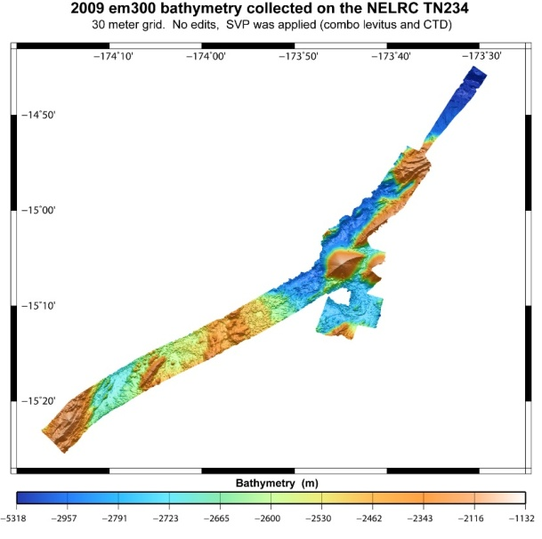

Tags
EM300, R/V Thomas G. Thompson, NOAA Vents Program
Summary
These multibeam bathymetry/backscatter data were collected during the TN234 Northeast Lau Basin Response Cruise (NELRC) expedition aboard the R/V Thomas G. Thompson May 5 - 13, 2009, Apia to Apia, Western Samoa.

Description
The main objective of the expedition was to visit the sites of two recent eruptions in the NE Lau Basin discovered on TN227. Bathymetry/backscatter data were collected during breaks in ROV operations.
The bathymetry data were cleaned using the MBSystem program, mbedit. New sound velocity profiles (created from CTD data collected during the expediton) were applied to the data postcruise. The 2009 did NOT need a +2 heading correction (the 2008 data did). NO heading correction was applied.

The data are final.
Credits
Joseph Resing, Chief Scientist (University of Washington) and Robert W. Embley, co-chief scientist (NOAA Vents Program), Questions regarding data processing, etc.: Susan G. Merle, Oregon State University (susan.merle@noaa.gov)
Access and use limitations
Not to be used for navigation.

